**LOGISTICS CLUSTER**

NATIONAL DISASTER RISK REDUCTION AND MANAGEMENT COUNCIL

**Software Development** | Asia Pacific College A.Y. 2017-2018

**Project Title:**

* NDRRMC – Logistics System

**Project Team:**

* Jimenez, Marc Adrian BSCS-CN Project Manager/ Assistant System Developer
* Abuel, Ferdinand Kenneth BSIT-MI System Developer
* Coronel, Sherine Jane BSCS-SS Documenter/Assistant Quality Assurance Analyst
* Dela Cruz, Joey Bernadette BSCS-CN Assistant Documenter/Quality Assurance Analyst

**Course Instructor:**

* Mr. Edmundo Casiño Project Adviser

**Client Agency:**

* NDRRMC | Office of Civil Defense – Logistics Cluster

**Client Logo:**

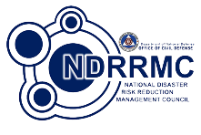

**TABLE OF CONTENTS**

ABSTRACT 3

INTRODUCTION 3

PROJECT DESCRIPTION 3

TARGET CLIENT 3

BRIEF BACKGROUND 3

PROBLEM STATEMENT 4

SITUATIONAL ANALYSIS 4

PROPOSED SOLUTION 4

EXPECTED OUTCOME 4

SYSTEM DIAGRAMS & TABLES 5

a. Context Level Diagram (Level 0 to Level 3 or 4) 5

b. Organizational Chart of Program Modules 6

c. Data Flow Diagram 7

d. Entity Relationship Diagrams 10

e. Database structure / Data tables 11

f. Data Dictionary 12

g. Screenshots per module 14

SOURCE CODE LISTINGS 24

REFERENCES 28

ABSTRACT

The NDRRMC – Logistics System is a cloud-based application program that keeps track of the available supplies, equipment, and vehicles, along with the various vital locations that will be essential in times of disaster. The system would mainly benefit the Logistics cluster since they are the one who is responsible for the *transportation*, *warehousing*, *inventorying*, and *tracking of deployed items*.

INTRODUCTION

National Disaster Risk Reduction and Management Council, also known as NDRRMC, is a working group of various organization that is responsible for formulating effective response schemes before, during, and after the calamity or disaster to ensure the protection and preservation of life, property, and the environment of affected communities. The NDRRMC is divided into 12 clusters for better task distinction and dissemination. These clusters are the Camp Coordination and Camp Management, Education, Emergency Telecom, Food & Non-Food Items, International Humanitarian Relations, Law and Order, Logistics, Management of the Dead and the Missing, Protection (IDP), Psycho Spiritual Integration, Search, Rescue, and Retrieval, and Water, Sanitation, Health (WaSH). (Office of Civil Defense, 2015)

Given the responsibilities of the NDRRMC, they still seek ways to improve their services to provide the society better assistance since the council still commits several lapses that may possibly harm the society due to the lack of proper management and allocation of resources, as well as the lack of proper utilization of role players in the event of a disaster or calamity. Therefore, the project team decided to develop a system that would streamline the NDRRMC processes by providing a digitized inventory system for supplies, equipment, and vehicles that will be essential in the event of disaster.

PROJECT DESCRIPTION

The NDRRMC - Logistics System was developed using Yii2, a generic web programming framework that is used for developing web applications with the use of PHP. PHP or Hypertext Preprocessor is a widely-used open source scripting language that contains HTML, CSS, and PHP code in order to generate dynamic page content for the system. PHP scripts are executed on the Apache web server which is installed and running on the EC2 (Amazon Elastic Compute Cloud) server, which was used to host the system via cloud. Processes that runs in the EC2 instance are the MariaDB and phpMyAdmin. MariaDB is a database management system, and phpMyAdmin is the management tool for MySQL.

TARGET CLIENT

The users of the system will be the Regional Admin, Provincial Admin, City/Municipal Admin, and the 12 different clusters of NDRRMC. With this, requests will then go through approvals based on the hierarchy of authority, therefore, the NDRRMC-Logistics cluster, will no longer have the need to contact each and every single one of the requestor from time to time to keep them informed. This will improve the management and organization of the cluster which can result to guaranteed response time in the event of disasters which in return, could turn out to be a benefit to the citizens of affected communities.

BRIEF BACKGROUND

The NDRRMC – Logistics cluster, headed by the Office of Civil Defense, acts as the lead office for Response Cluster in disaster response operations. They take charge in providing efficient and effective logistical support among the concerned OCD authority personnel, other cluster members and logistics partners. As well as, establishing standard operating procedures on pre-disaster, during disaster, and post-disaster phase which involves inventory of available assets and resources, procurement and allocation of assets and resources, receives and facilitates requests for logistical support, provides feedback to requesting DRRMCs and local government of affected areas, tracking of cargo to its destination, updates on road conditions, warehouses stocks and cargo capacities, and other logistics services. (Office of Civil Defense, 2015)

PROBLEM STATEMENT

The Logistics cluster handles tons of workload knowing their responsibilities as the lead agency for disaster response operations. Overall, the common problem that needs to be addressed in times of disaster response operations are the lack of coordination, cooperation and communication among different government agencies which leads to disorderly procurement and allocation of resources, duplication of requests, inaccurate inventory, unsystematic organization, missing cargo, and scarcity due to improper handling of supplies.

SITUATIONAL ANALYSIS

The NDRRMC is divided into 12 clusters, with each having their own set of tasks to accomplish. The main goal of this project is the Logistics cluster, which aims to harmonize the activities of all clusters and encourages regular data exchange among all stakeholders regarding with the *Transportation, Warehousing, Inventories, and the Tracking of deployed items*.

The main problem of the Logistics cluster that needs to be addressed is the info-sharing between the different clusters. Consequently, this problem induces additional problems pertaining to (1) transportation such as facility location and vehicle routing; (2) procurement, which is the requesting process of resources; (3) and deployment, which involves the LAN infrastructure reliability of the system. Leaving these problems unsolved will affect the mission of the NDRRMC as well as the welfare of the affected societies.

PROPOSED SOLUTION

The proposed solution to the issues of NDRRMC are: (1) Condense the user list by ordering them based on the type of user for a simpler User Management, (2) Digitized inventory management that could keep track of the available resources and monitor the requests, (3) Centralize records of information of the resources and its suppliers, which can be viewed, edited, and deleted, (4) Deployment of the system to a Cloud Platform for more guaranteed runtime.

EXPECTED OUTCOME

The outcome of the Logistics System may improve the response operation phase of NDRRMC given that this system will provide a methodical impact to the council. It will maximize effective logistical support since the system promotes regular info-sharing of relevant records of data between the local government and agencies. Besides, requesting of supplies, equipment, and vehicles that will be needed in times of disasters can be immediately accomplished in a short span of time by the system provides a digitized inventory system. Also, users can access the web application without difficulty as long as they have a stable internet connection.

SYSTEM DIAGRAMS & TABLES

## Context Level Diagram (Level 0 to Level 3 or 4)

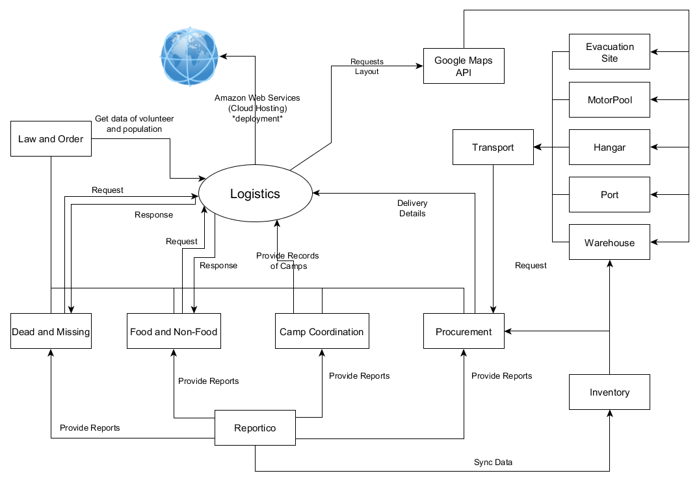

## Organizational Chart of Program Modules

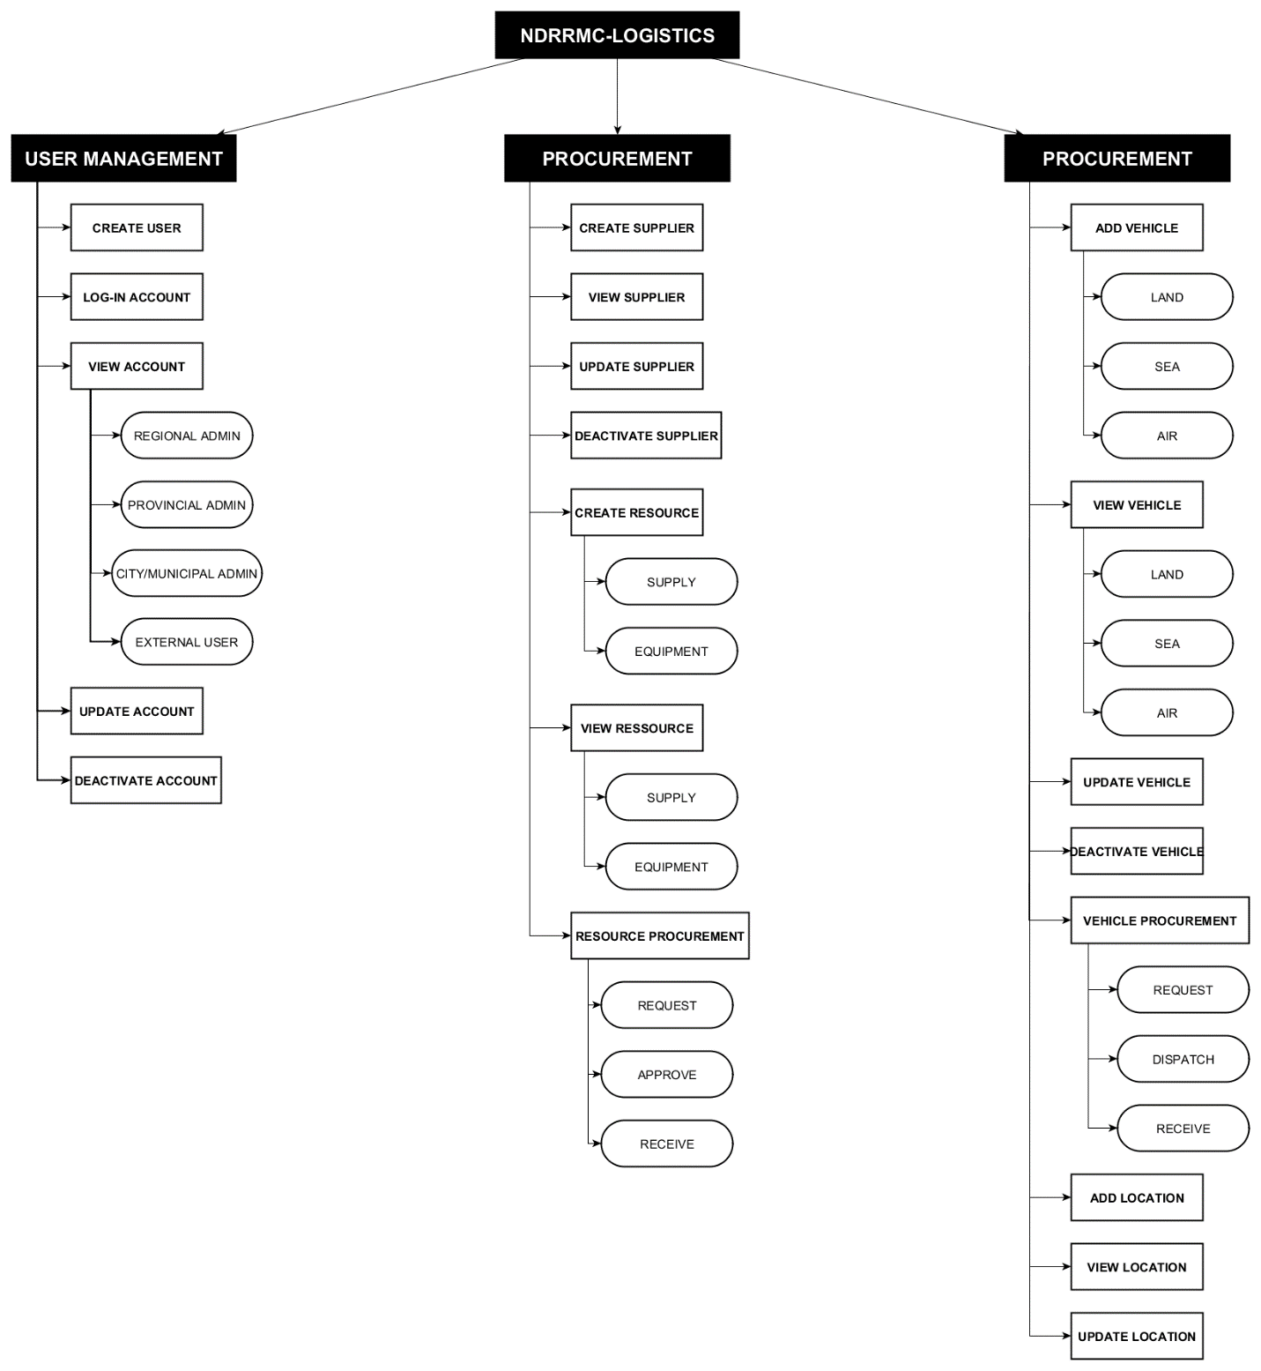

## Data Flow Diagram

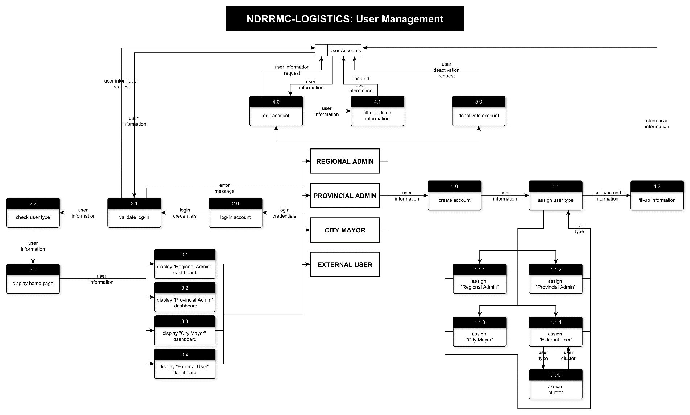

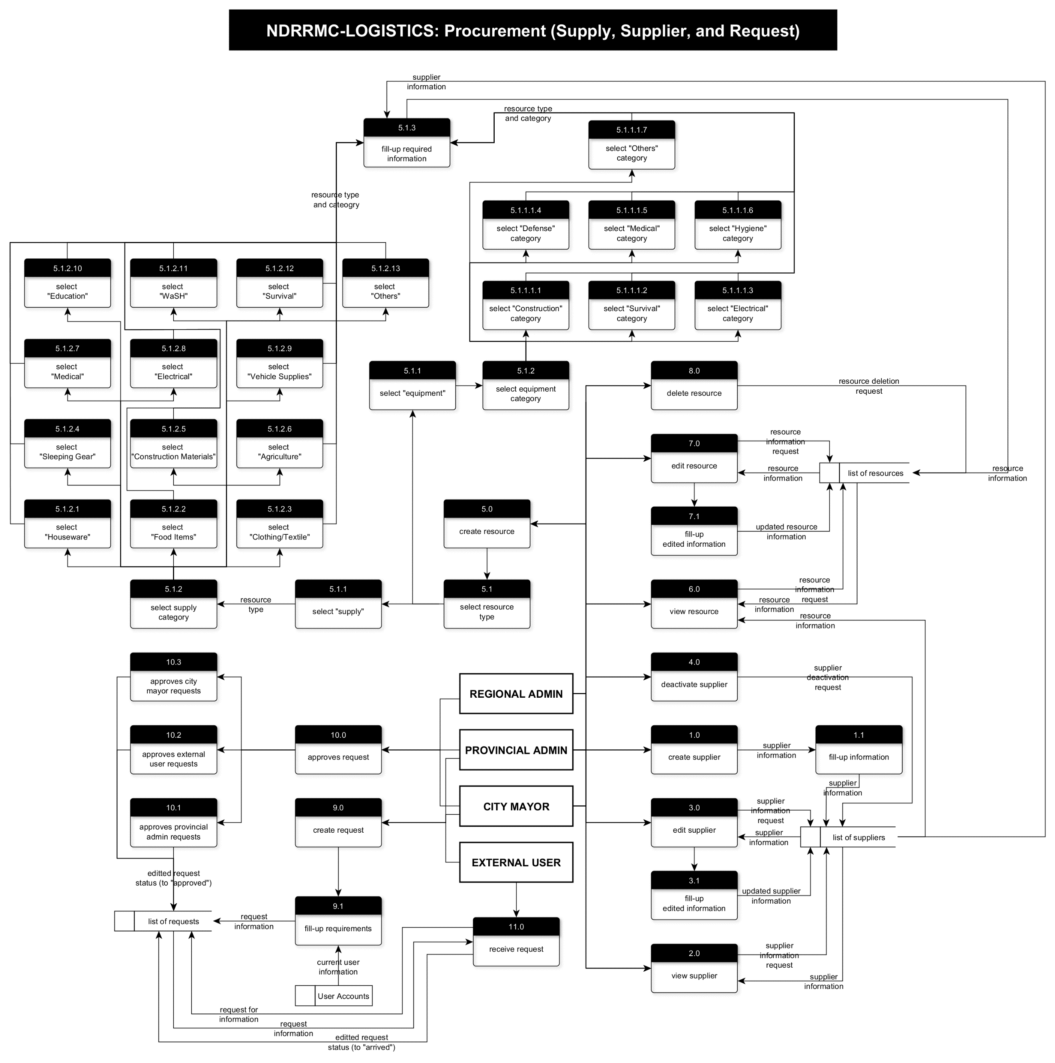

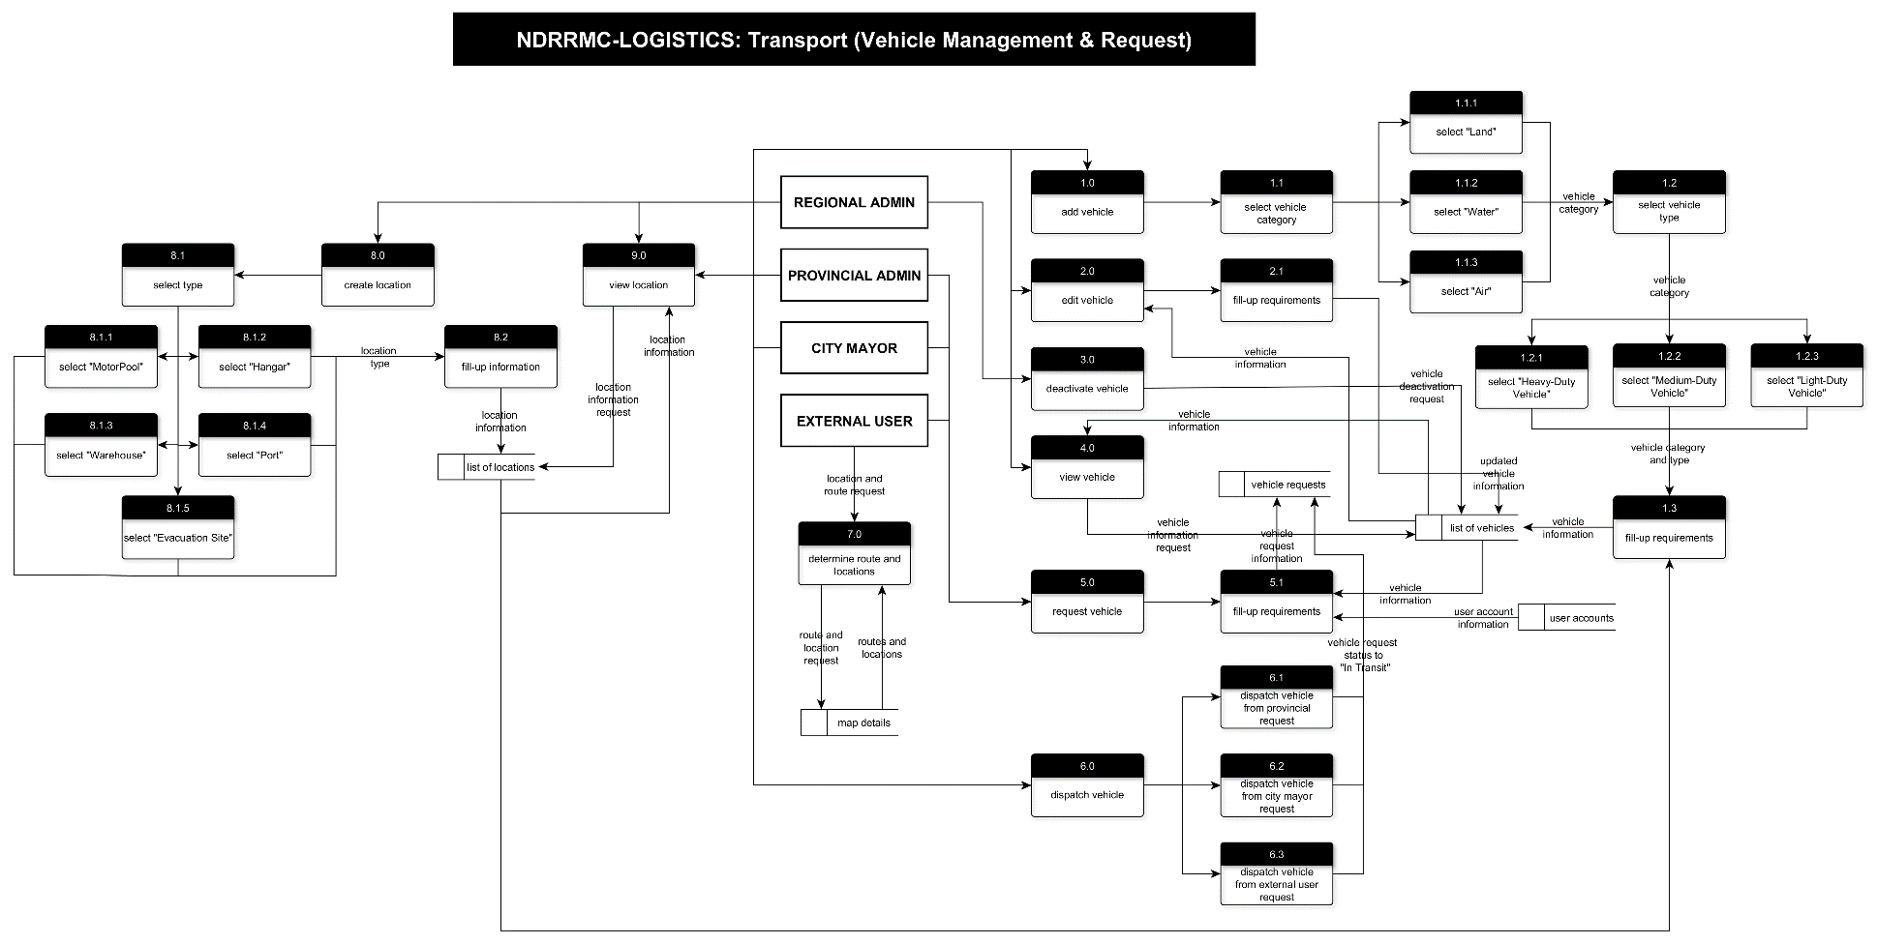

## Entity Relationship Diagrams

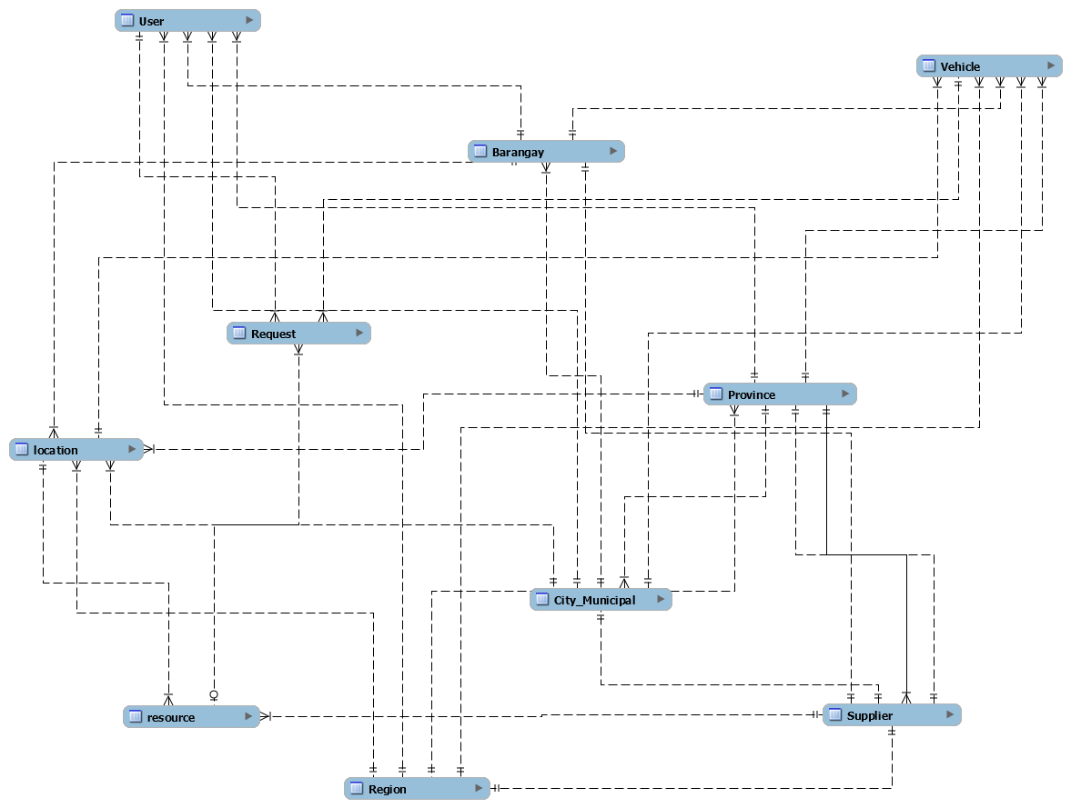

## Database structure / Data tables

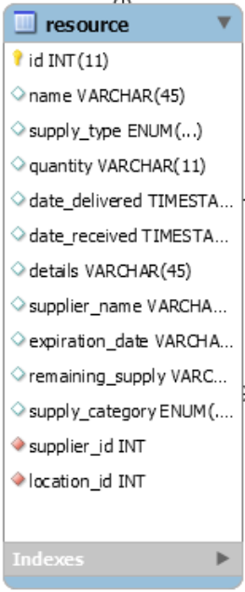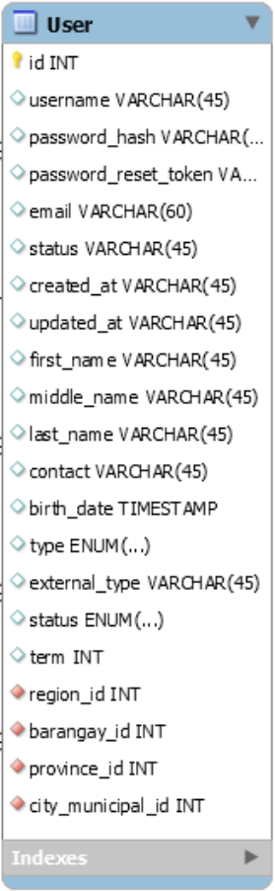

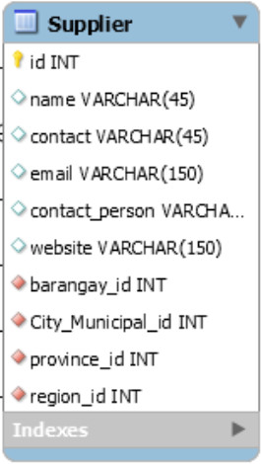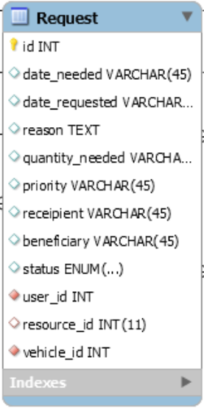`

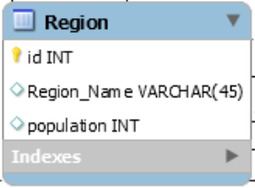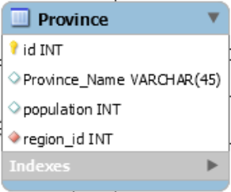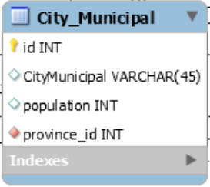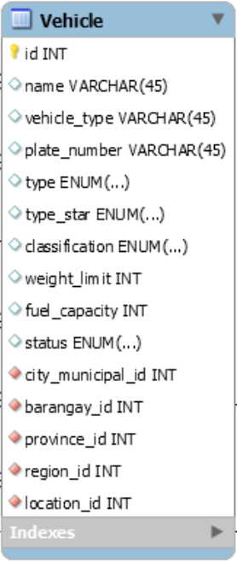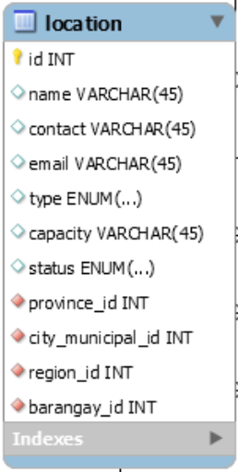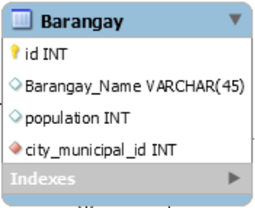

## Data Dictionary

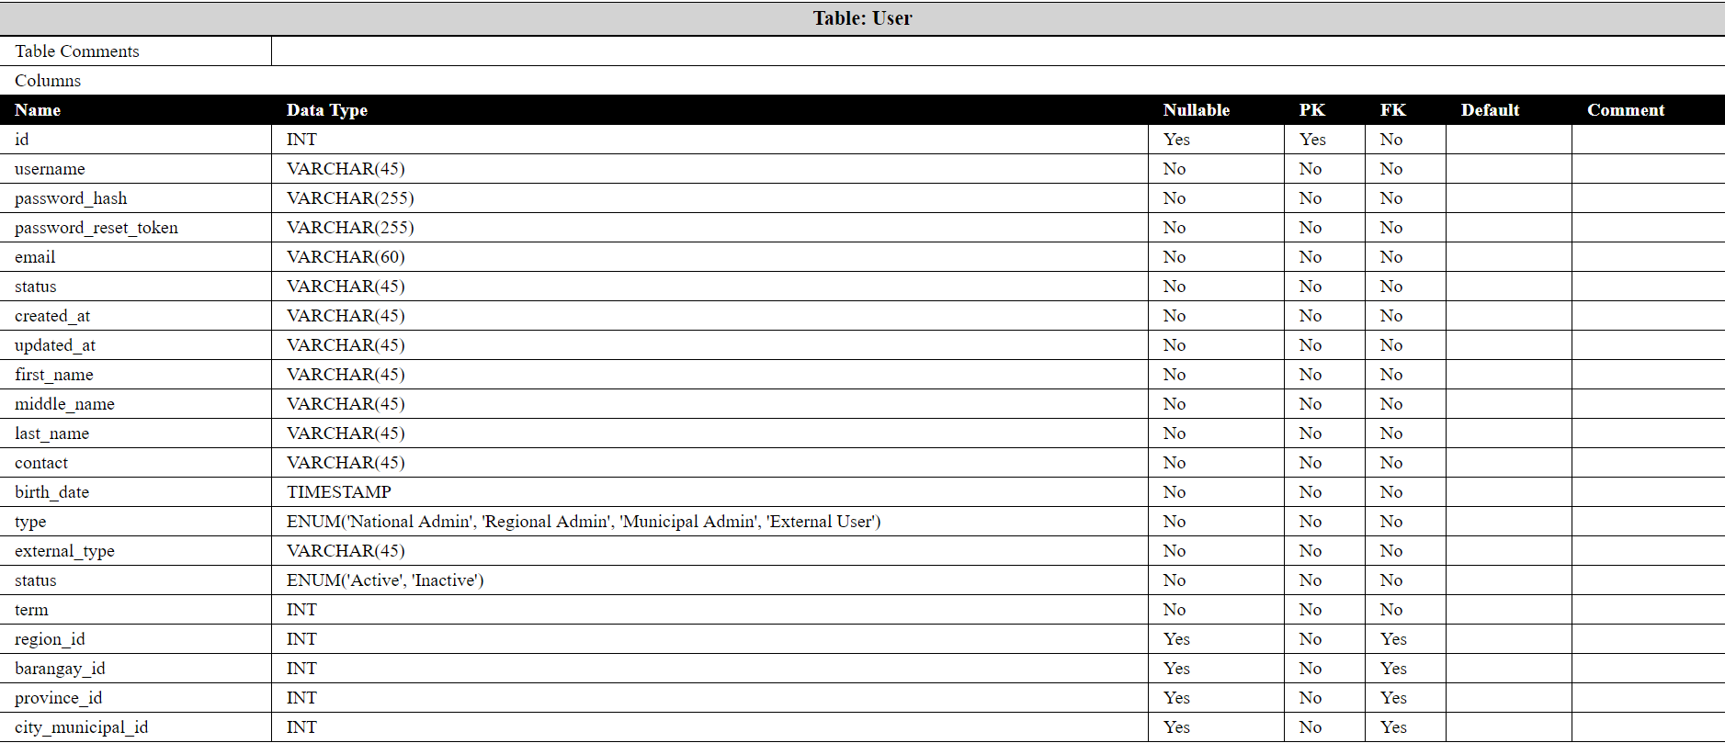

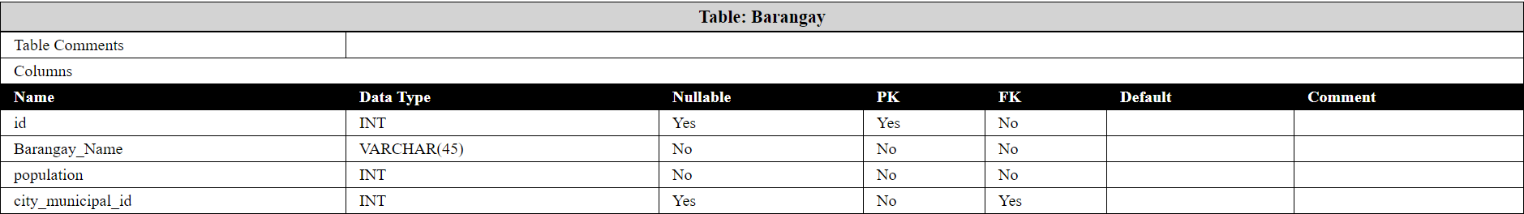

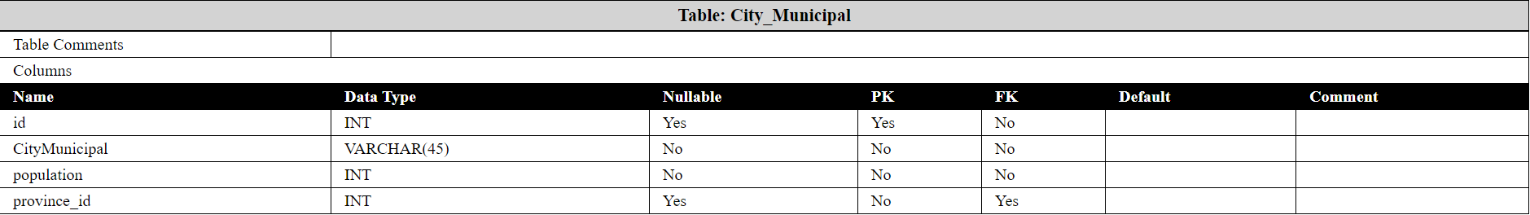

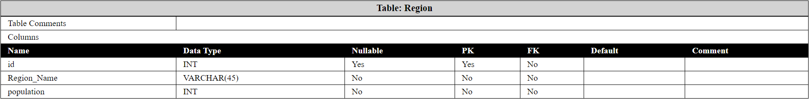

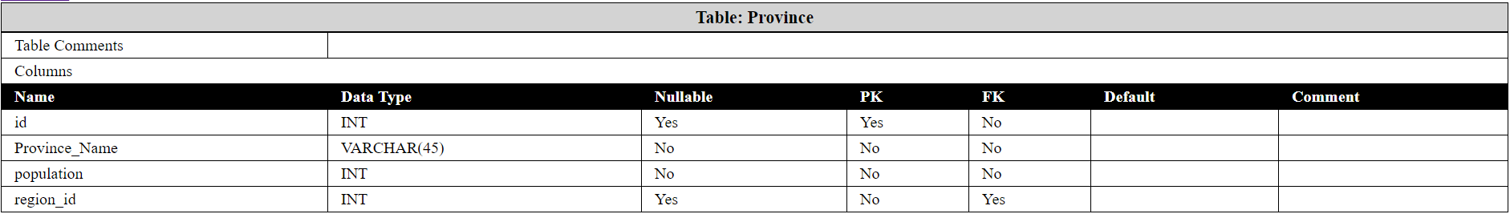

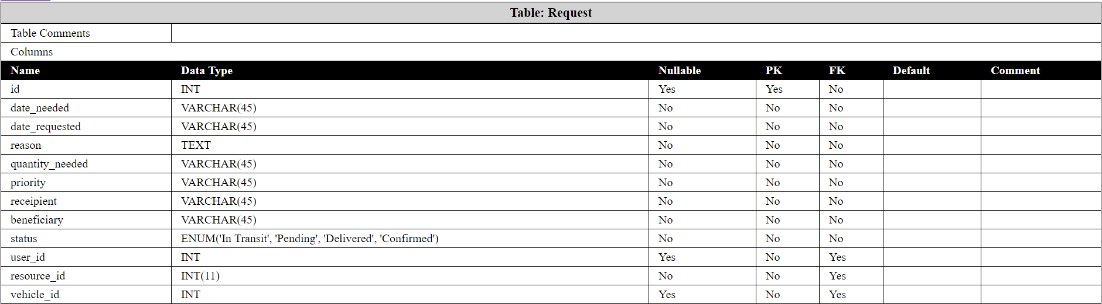

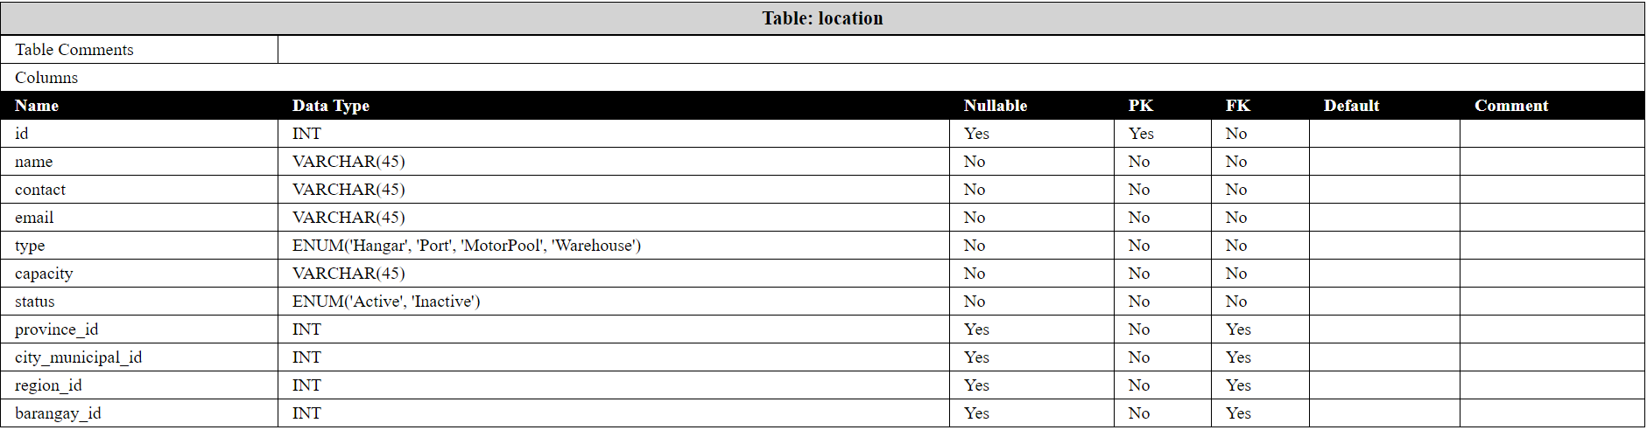

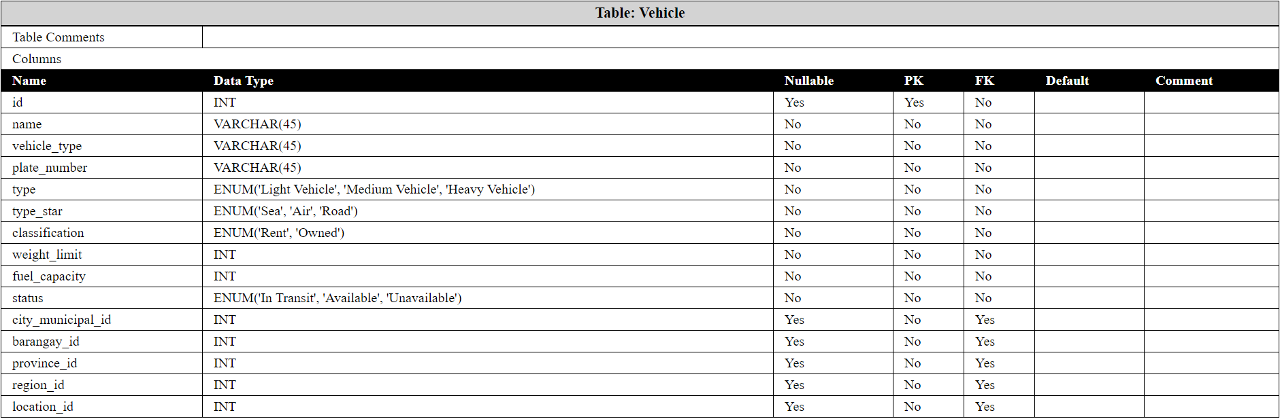

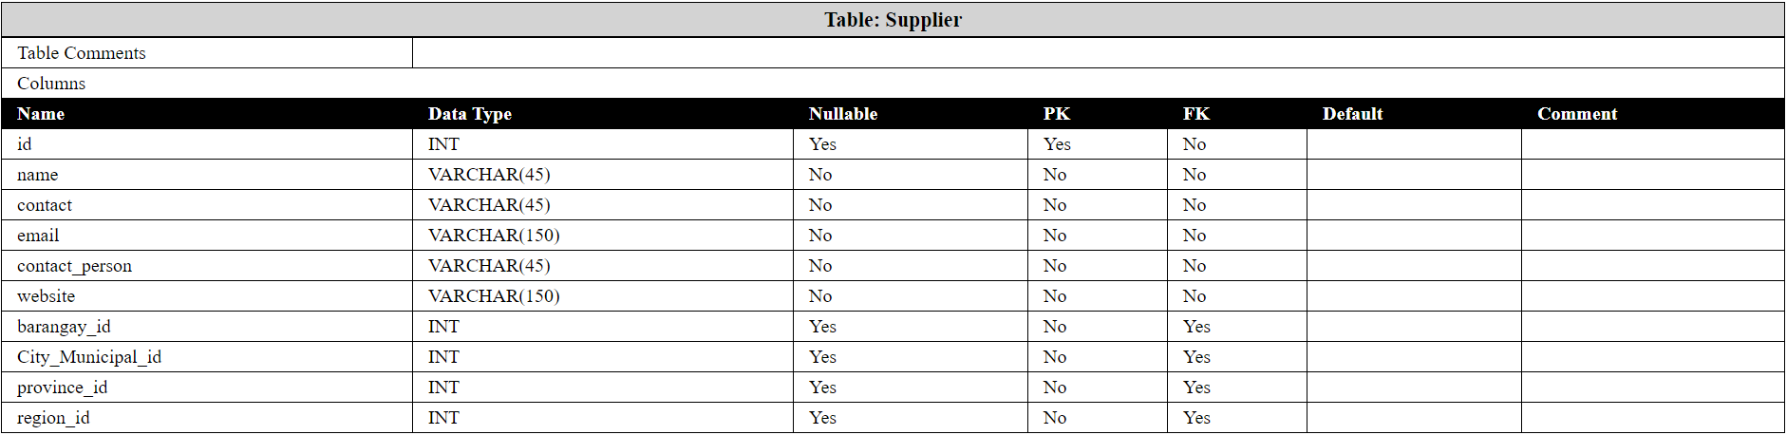

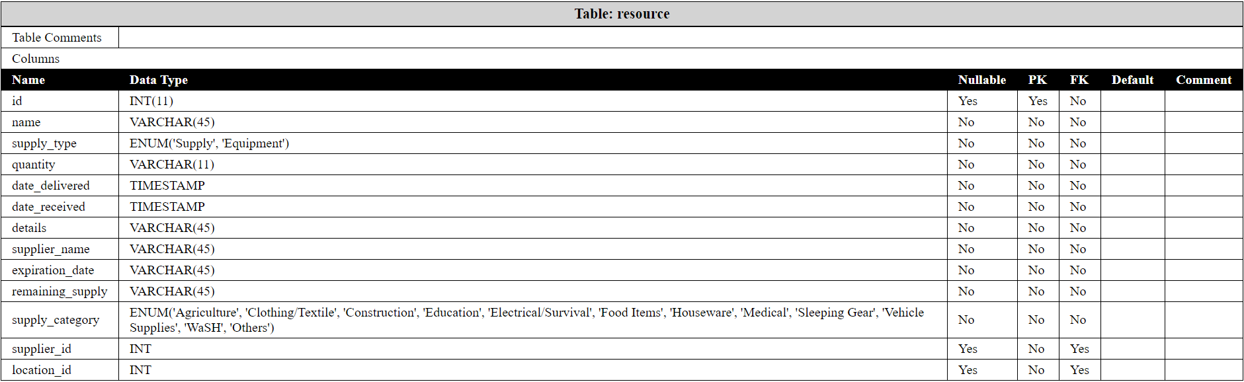

## Screenshots per module

This system is composed of 3 major modules, namely *User Management*, *Procurement*, and *Transport*. For the User Management, it basically handles the different users that the system caters to: Regional Admin, Provincial Admin, City-Municipal Admin, and the External Users (which consists of the 12 different cluster groups of the NDRRMC). The Procurement Module the records needed to acquire resources. This module revolves around the Suppliers, Resources (which are divided into two categories; Supplies which are easily exhausted, and the Equipment, which lasts long as compared to supplies.), and the Requests of the aforementioned resources. Lastly, the Transport module which handles the delivery of items from one point to another, this tackles the records of Vehicles and the Locations.

For the **User Management**, we have the following procedures:

1. Signing up of Users

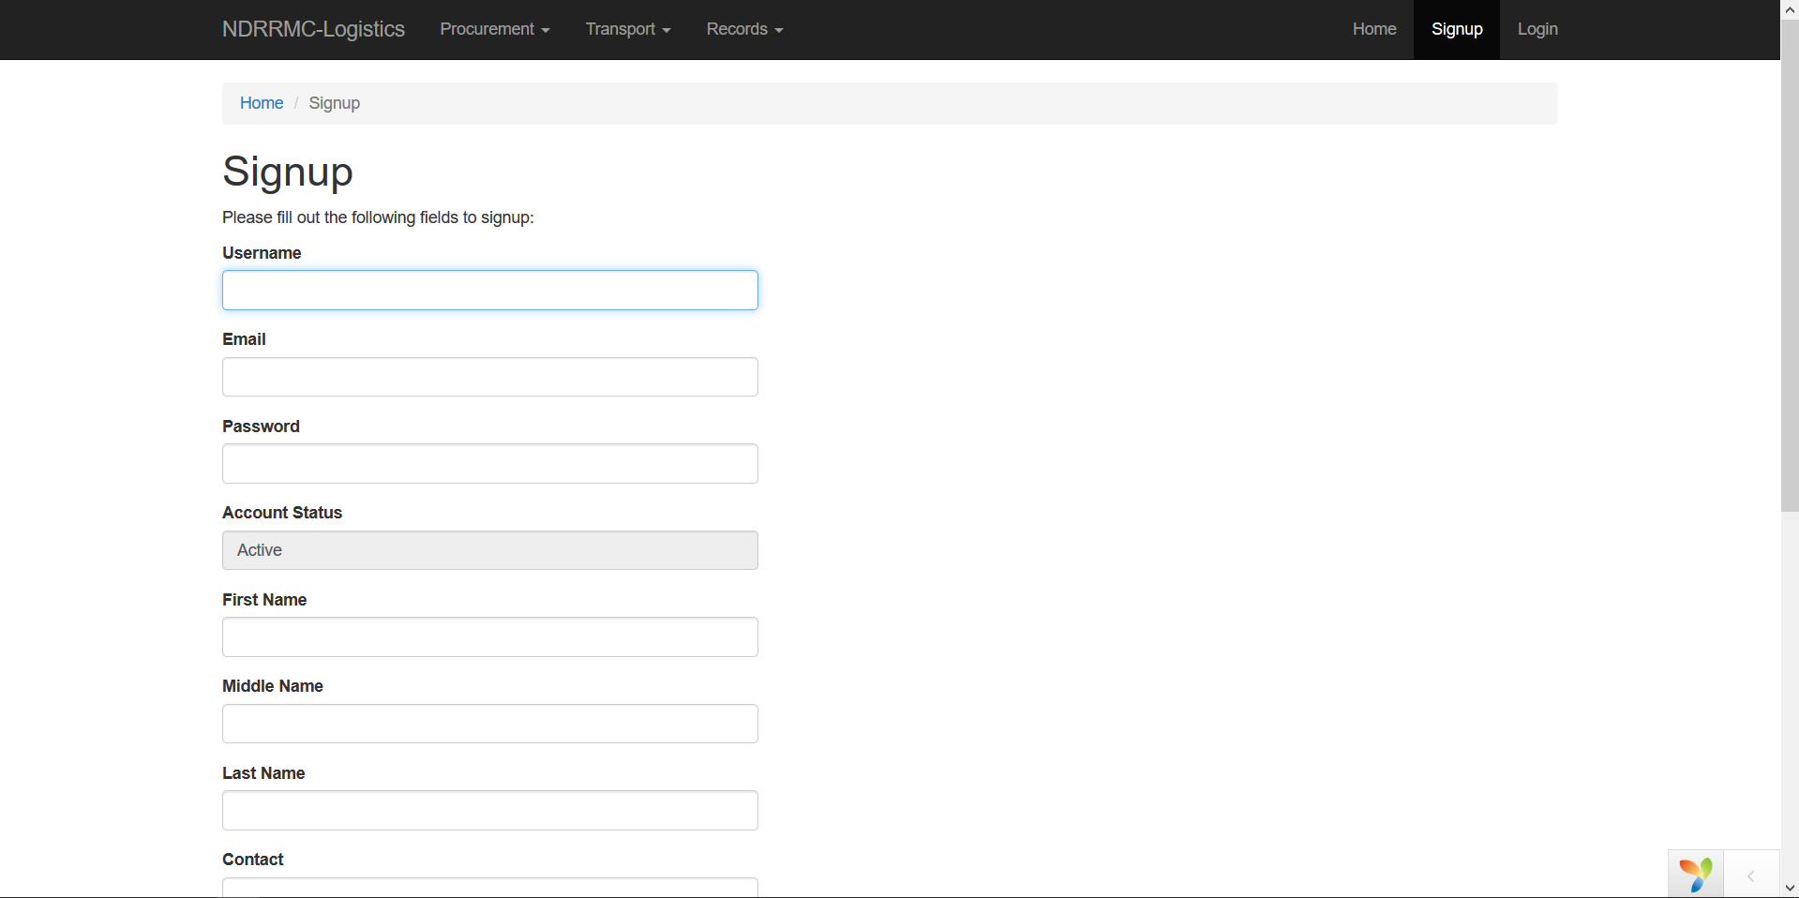

1. Logging in of the User

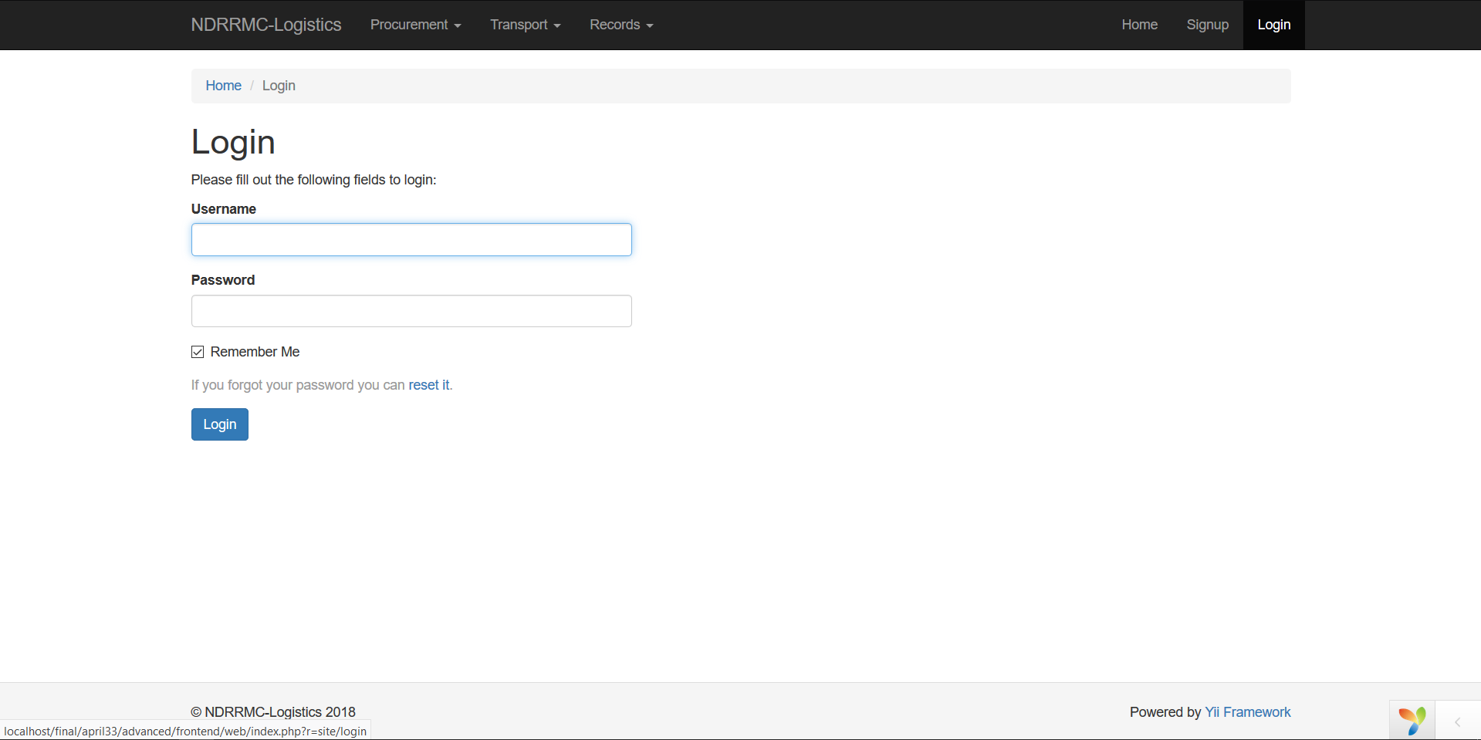

1. Viewing of the Users

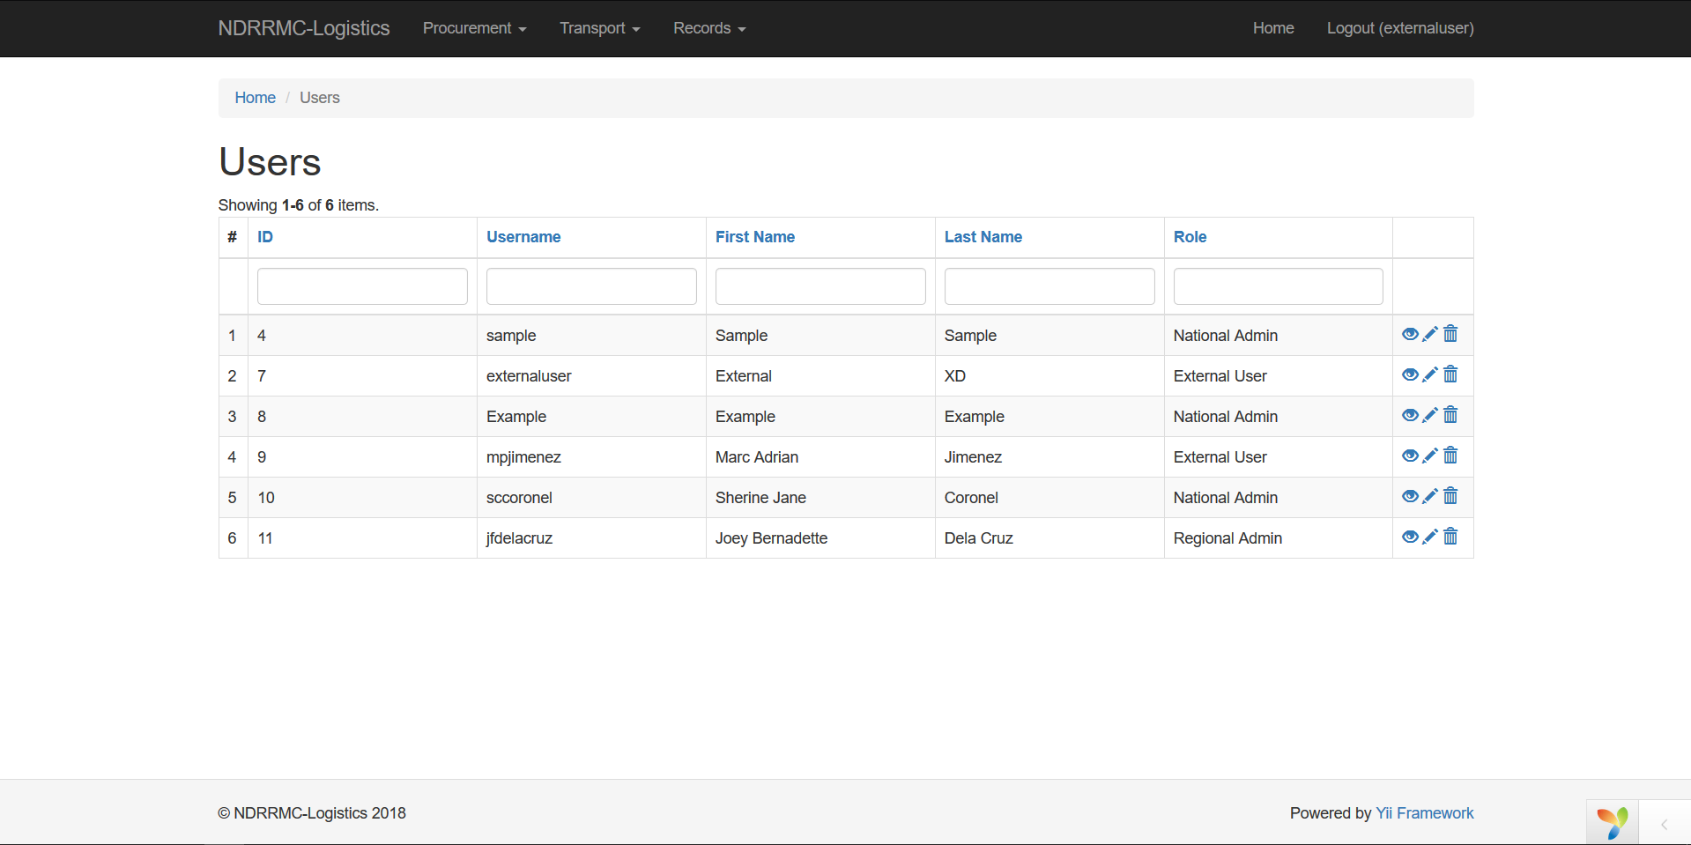

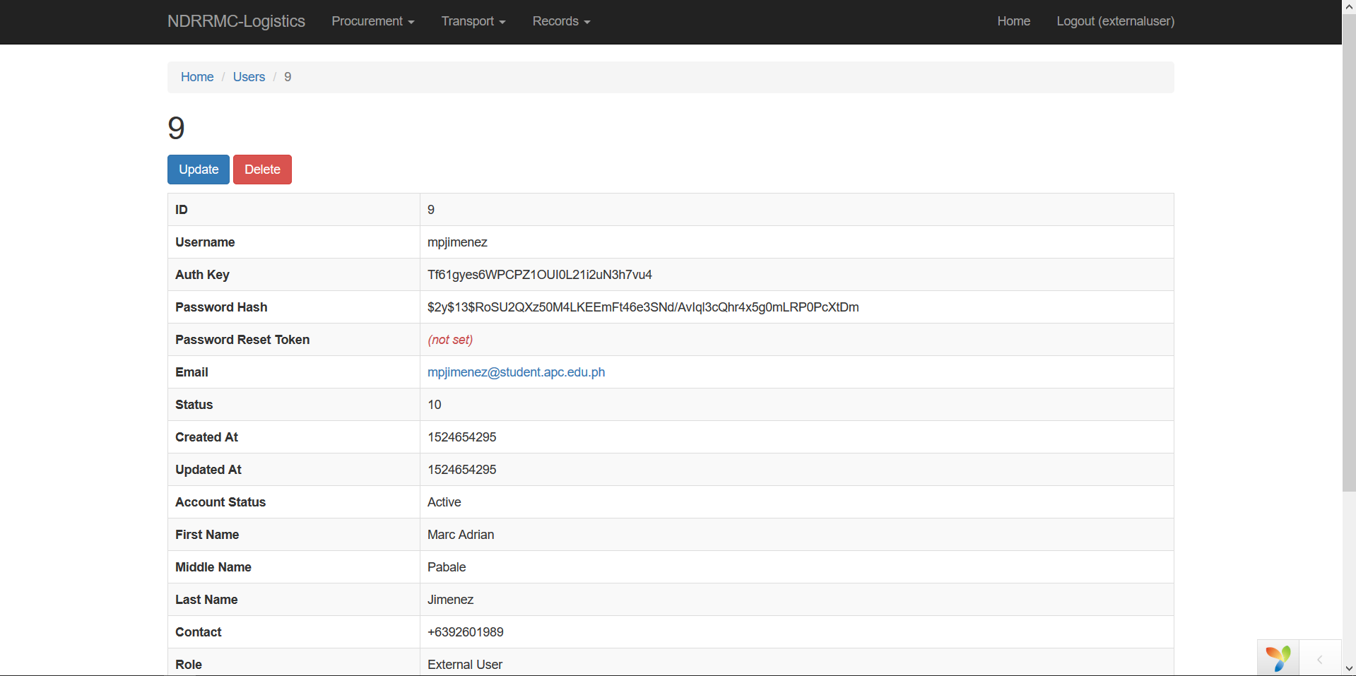

1. Updating the User

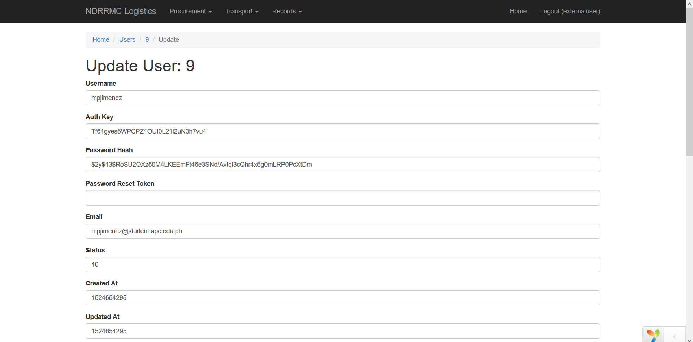

For the **Procurement Module**, we have the following procedures

1. Creating of Suppliers

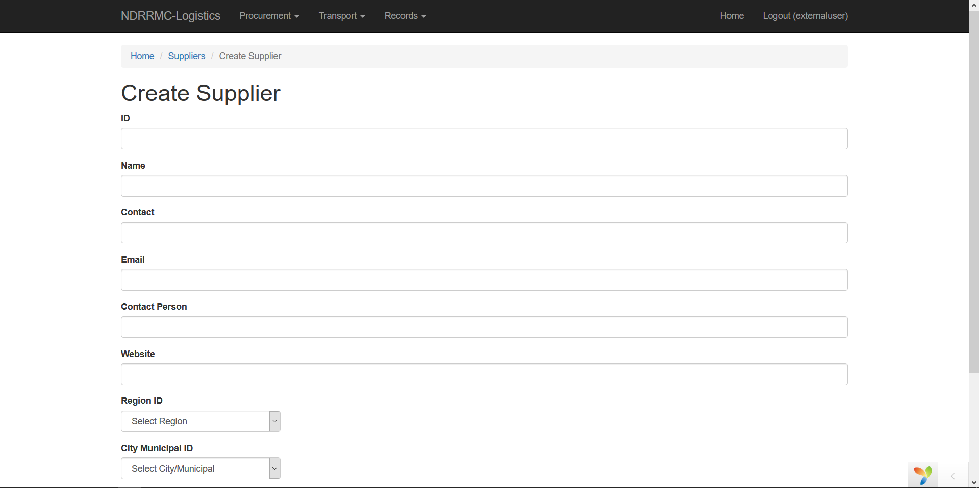

1. Viewing Suppliers

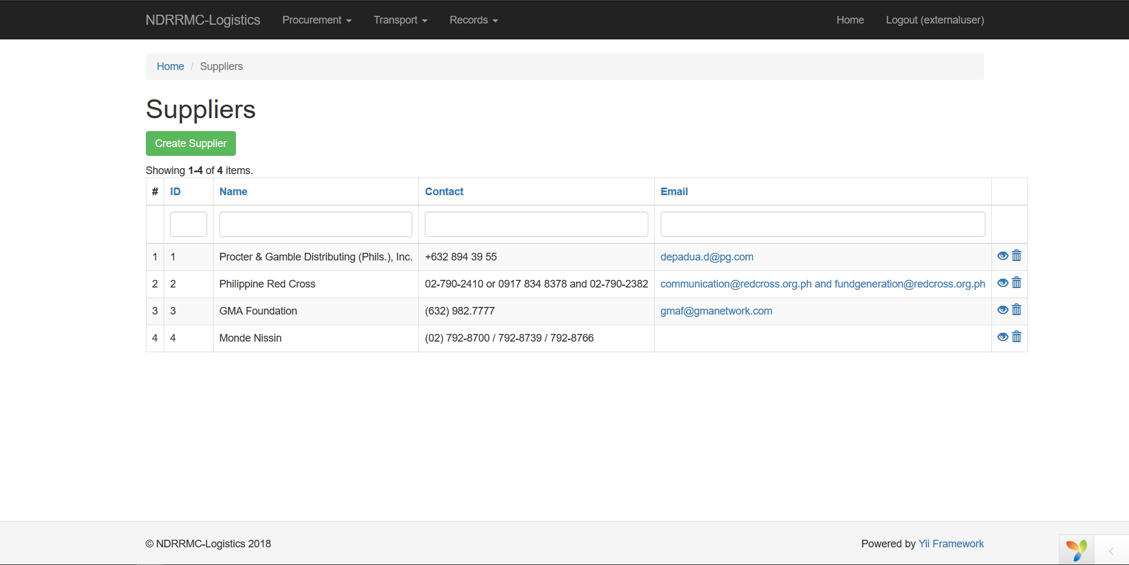

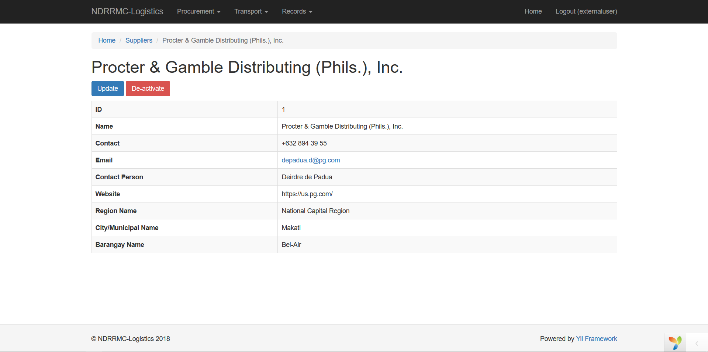

1. Updating Suppliers

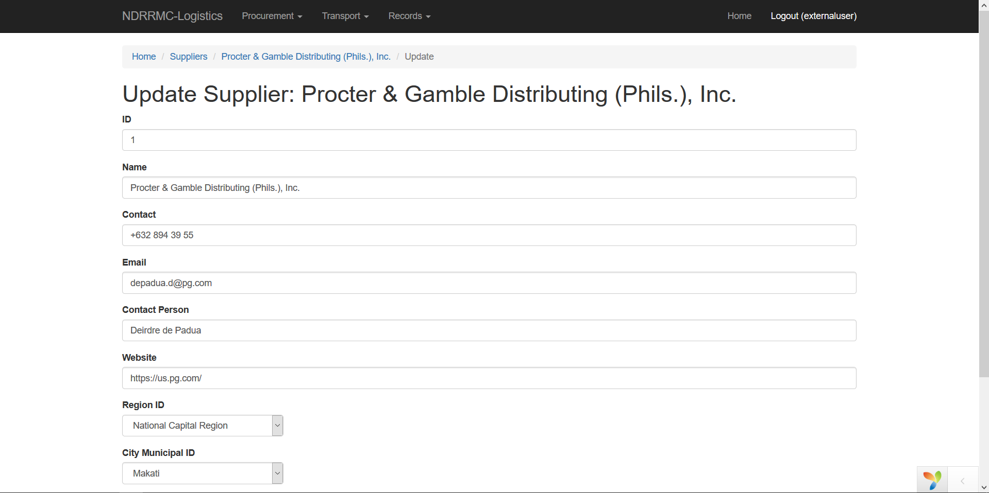

1. Creating of Resources

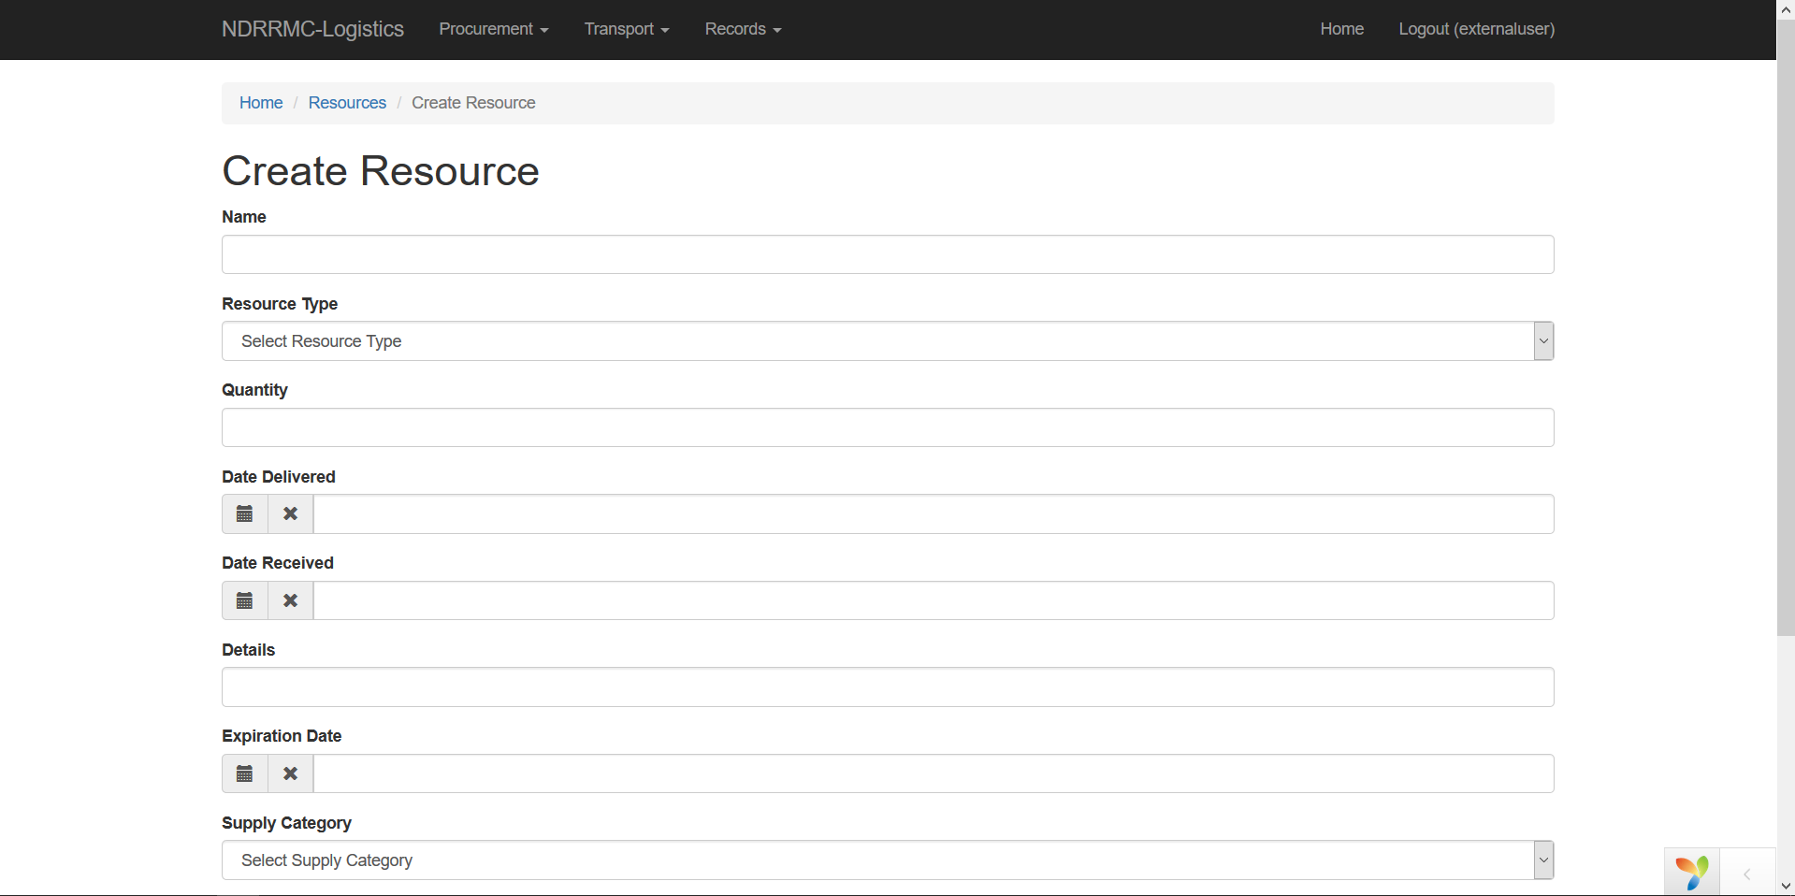

1. Viewing of Resources

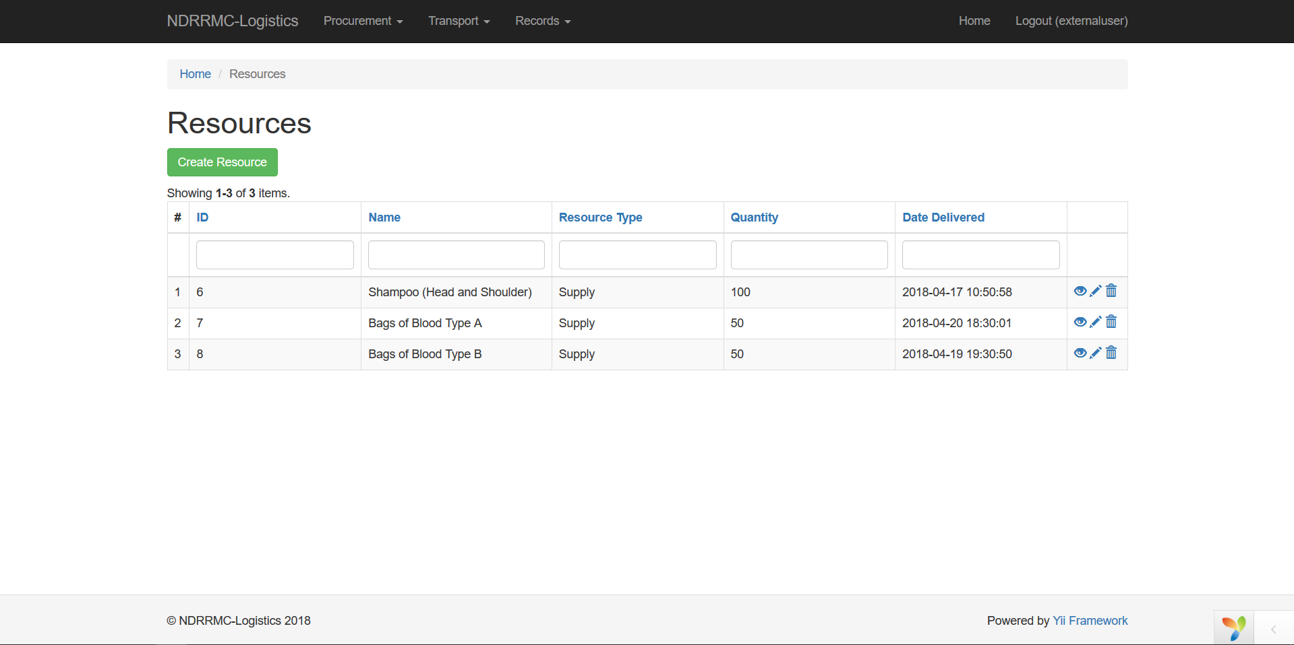

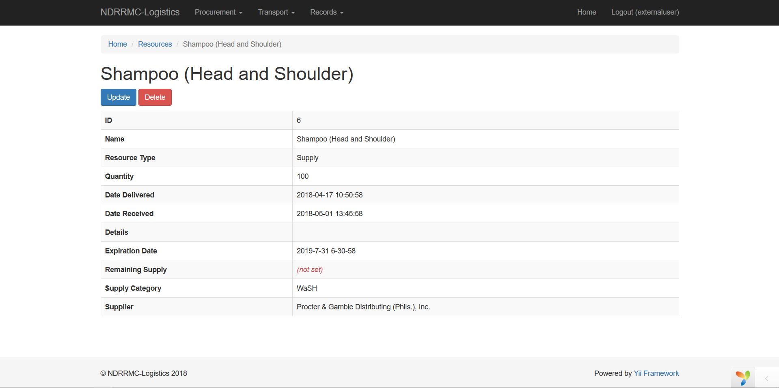

1. Updating Resources

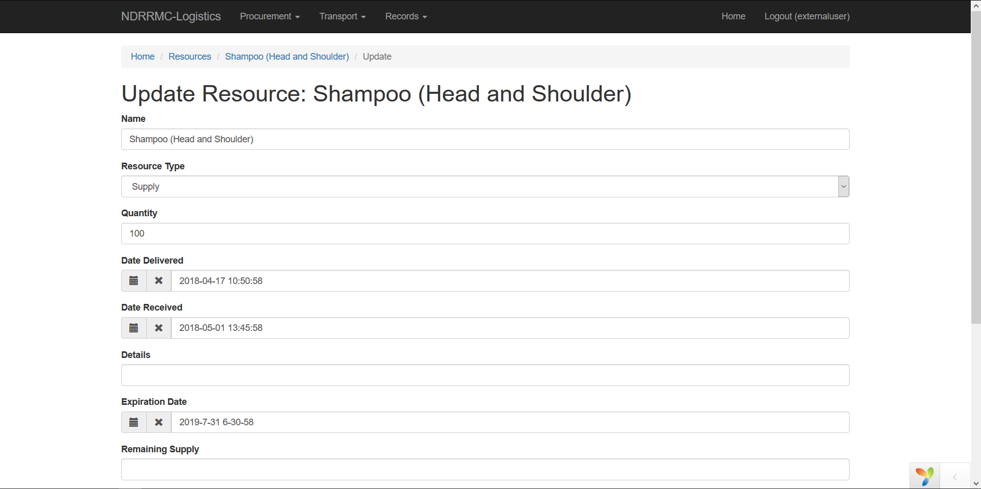

1. Creating Requests

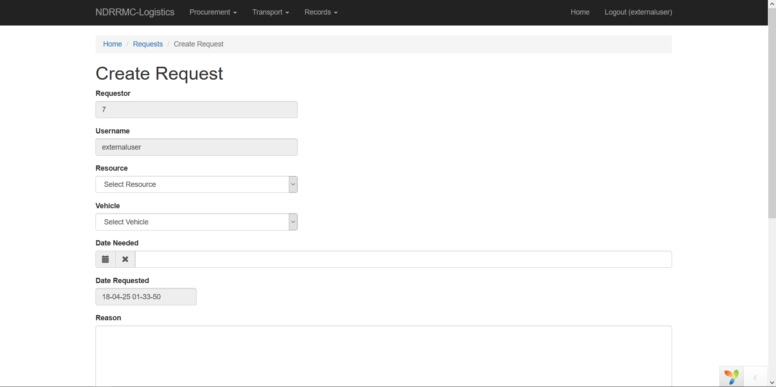

1. Viewing Requests

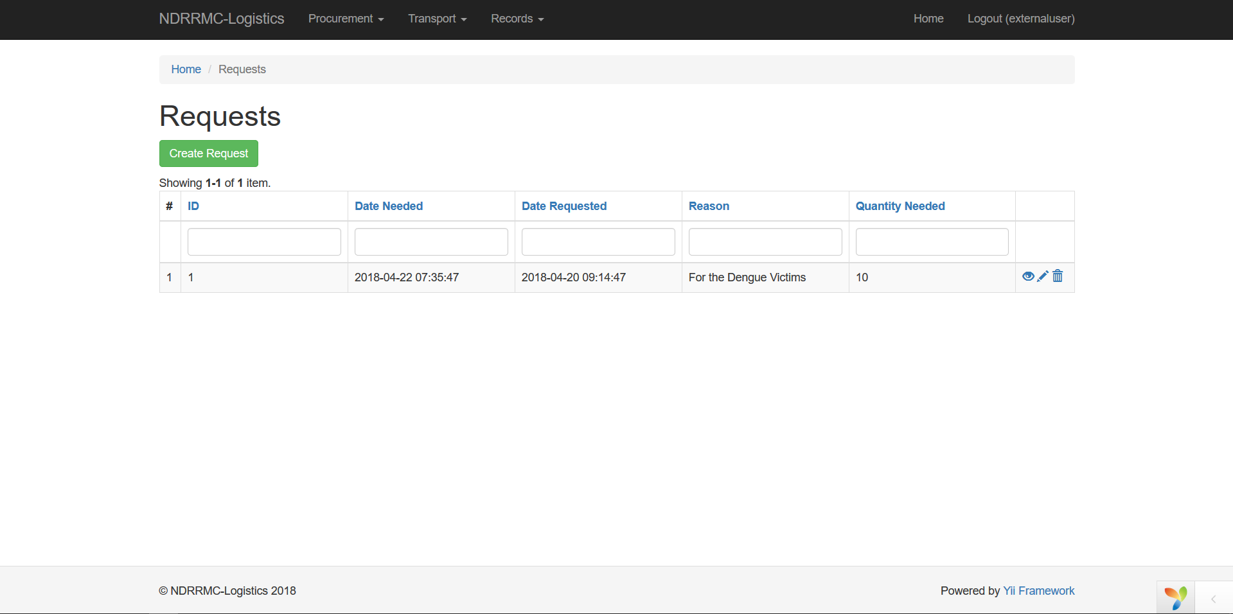

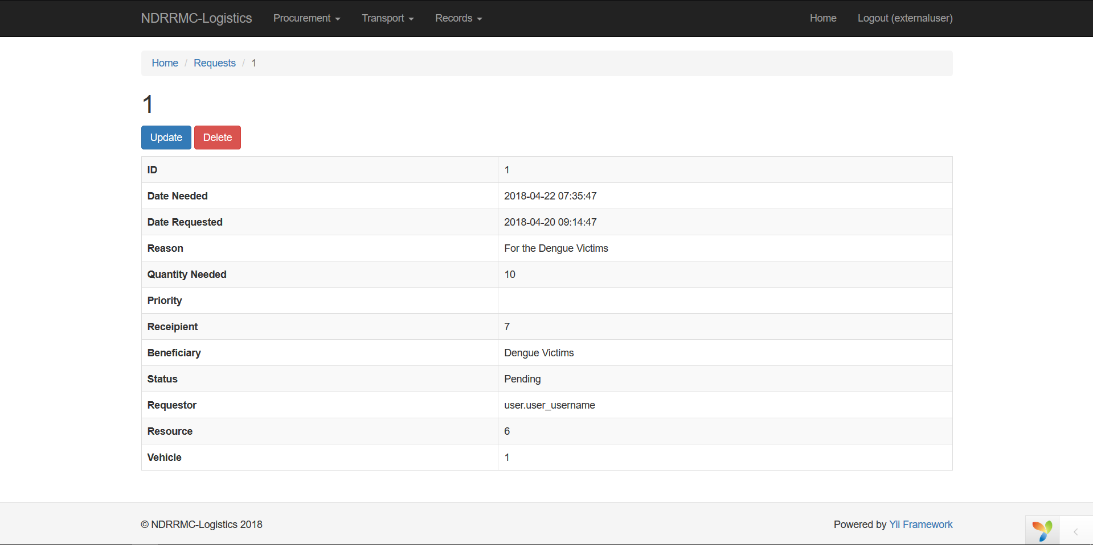

1. Updating Requests

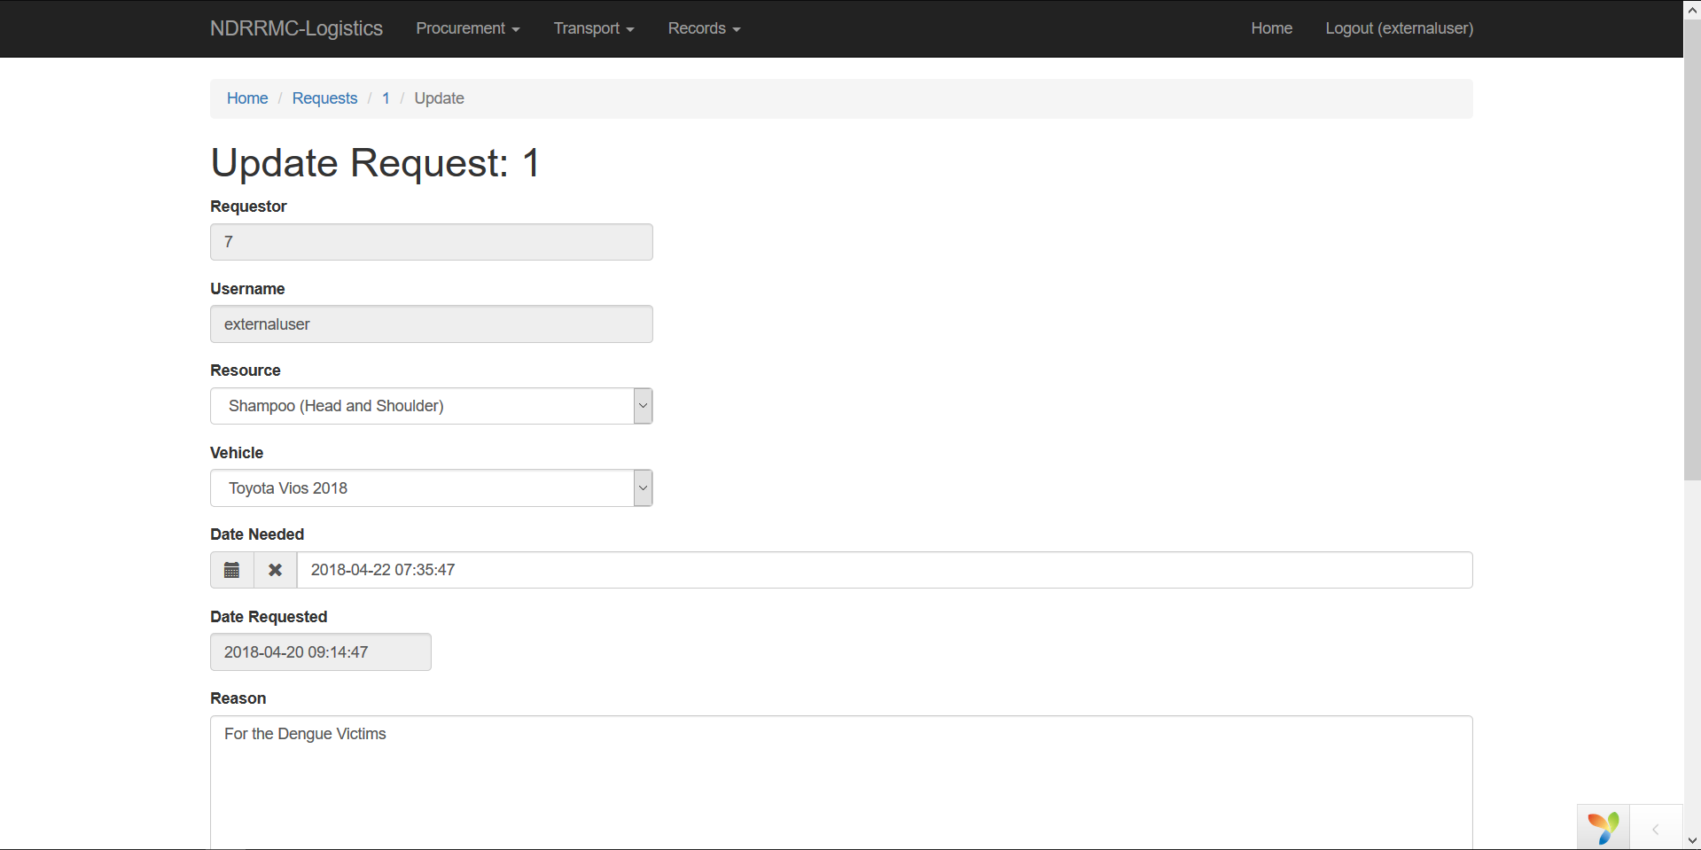

For the **Transport Module**, we have the following procedures:

1. Creating Locations

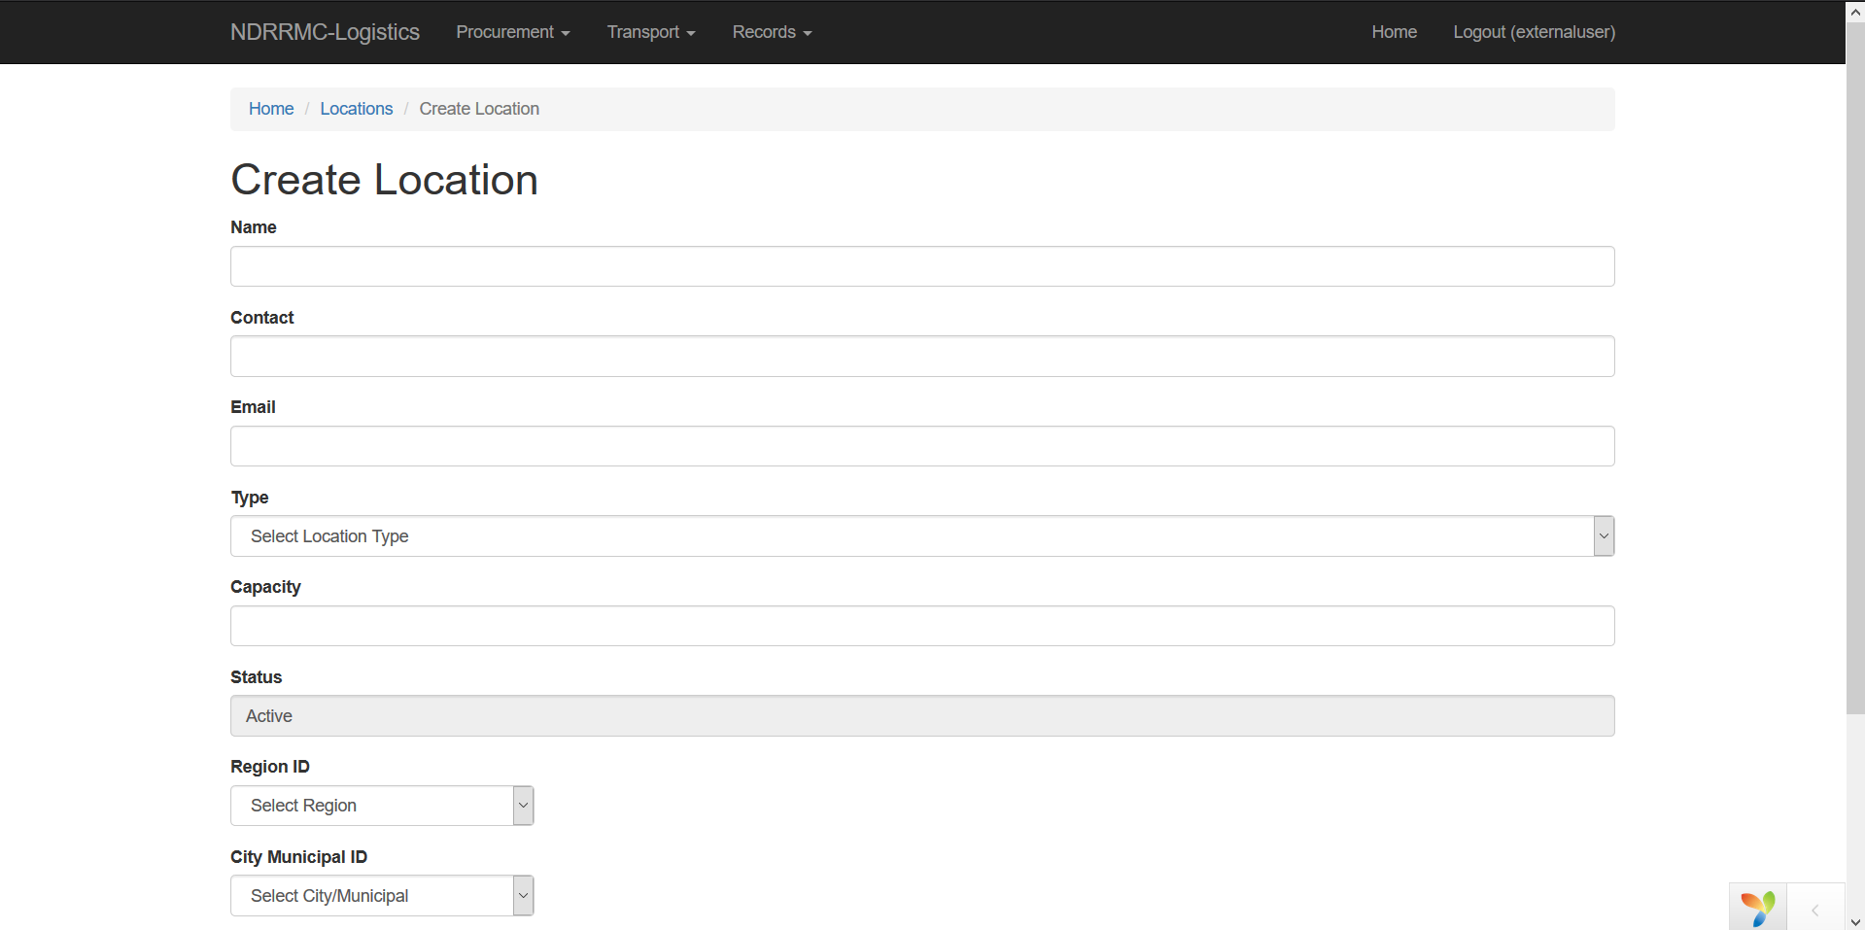

1. Viewing Locations

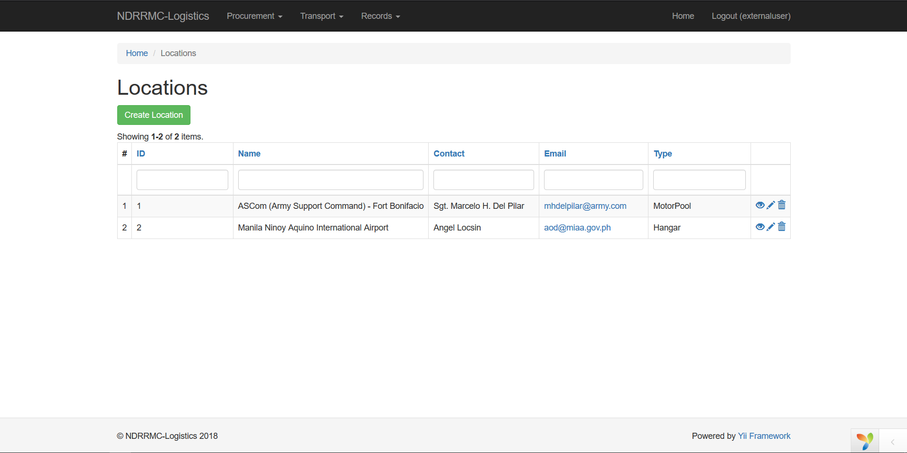

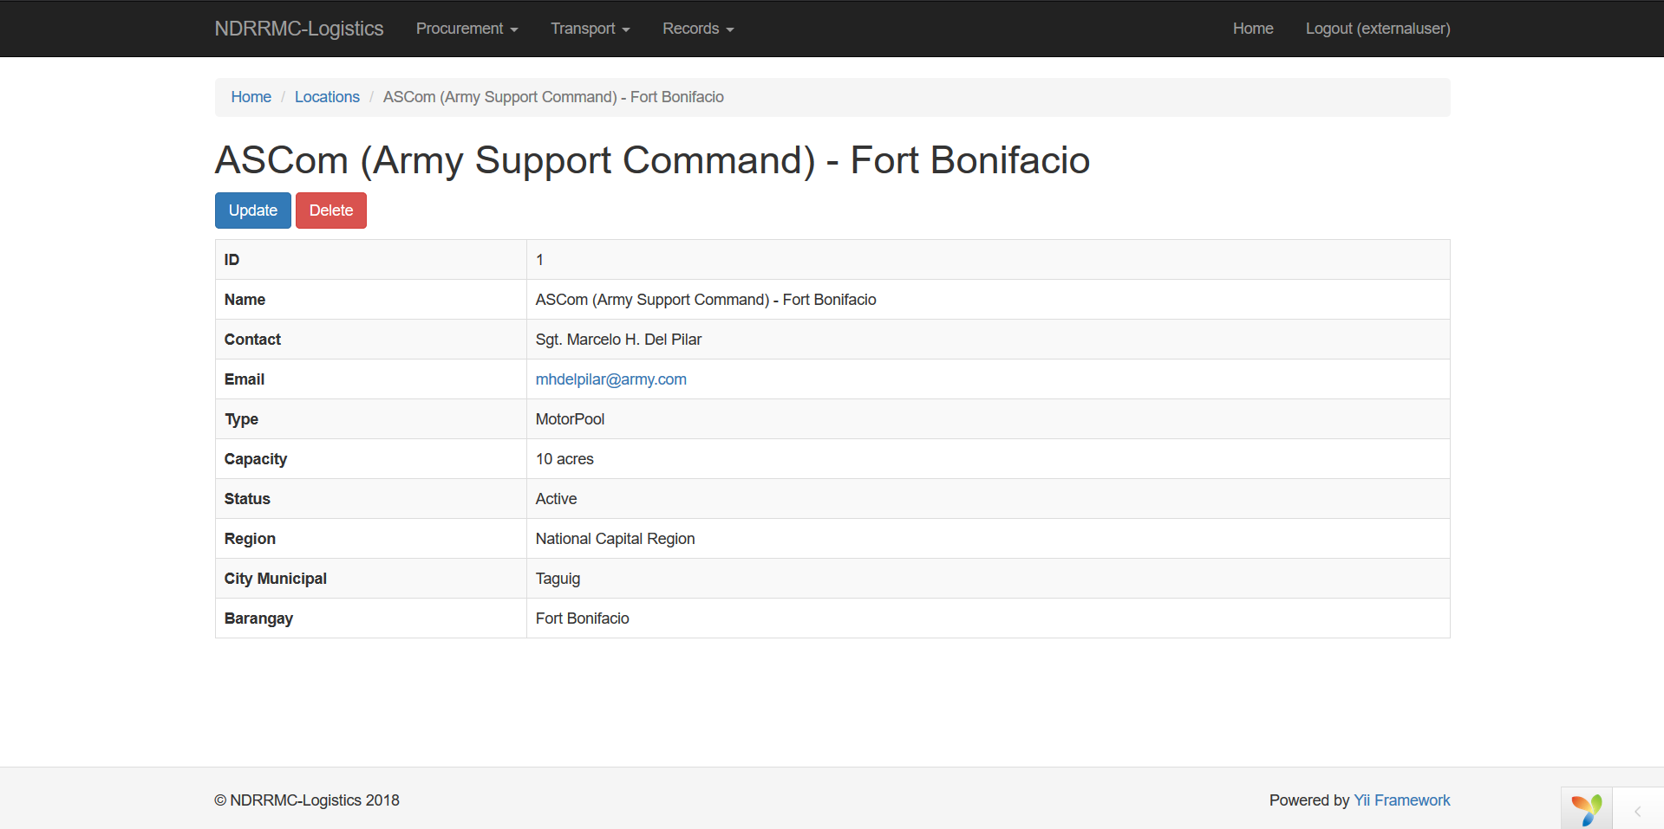

1. Updating Locations

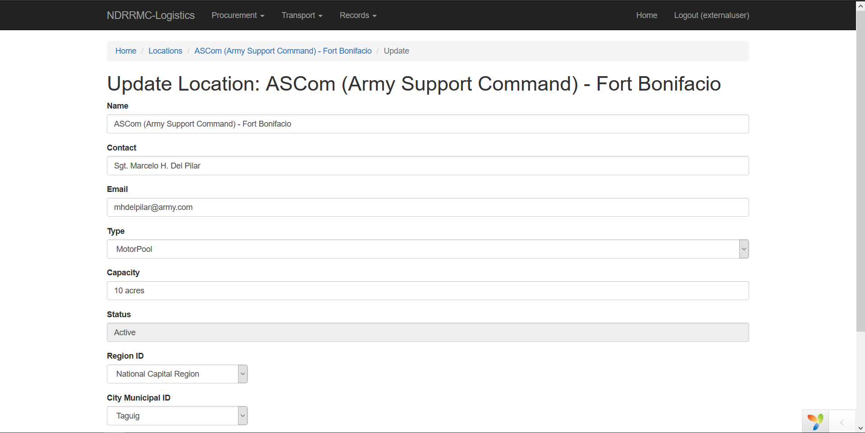

1. Creating Vehicles

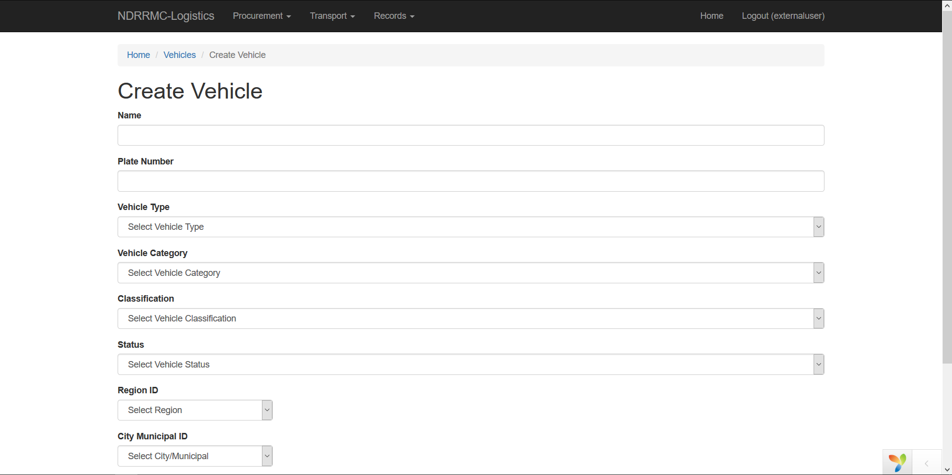

1. Viewing Vehicles

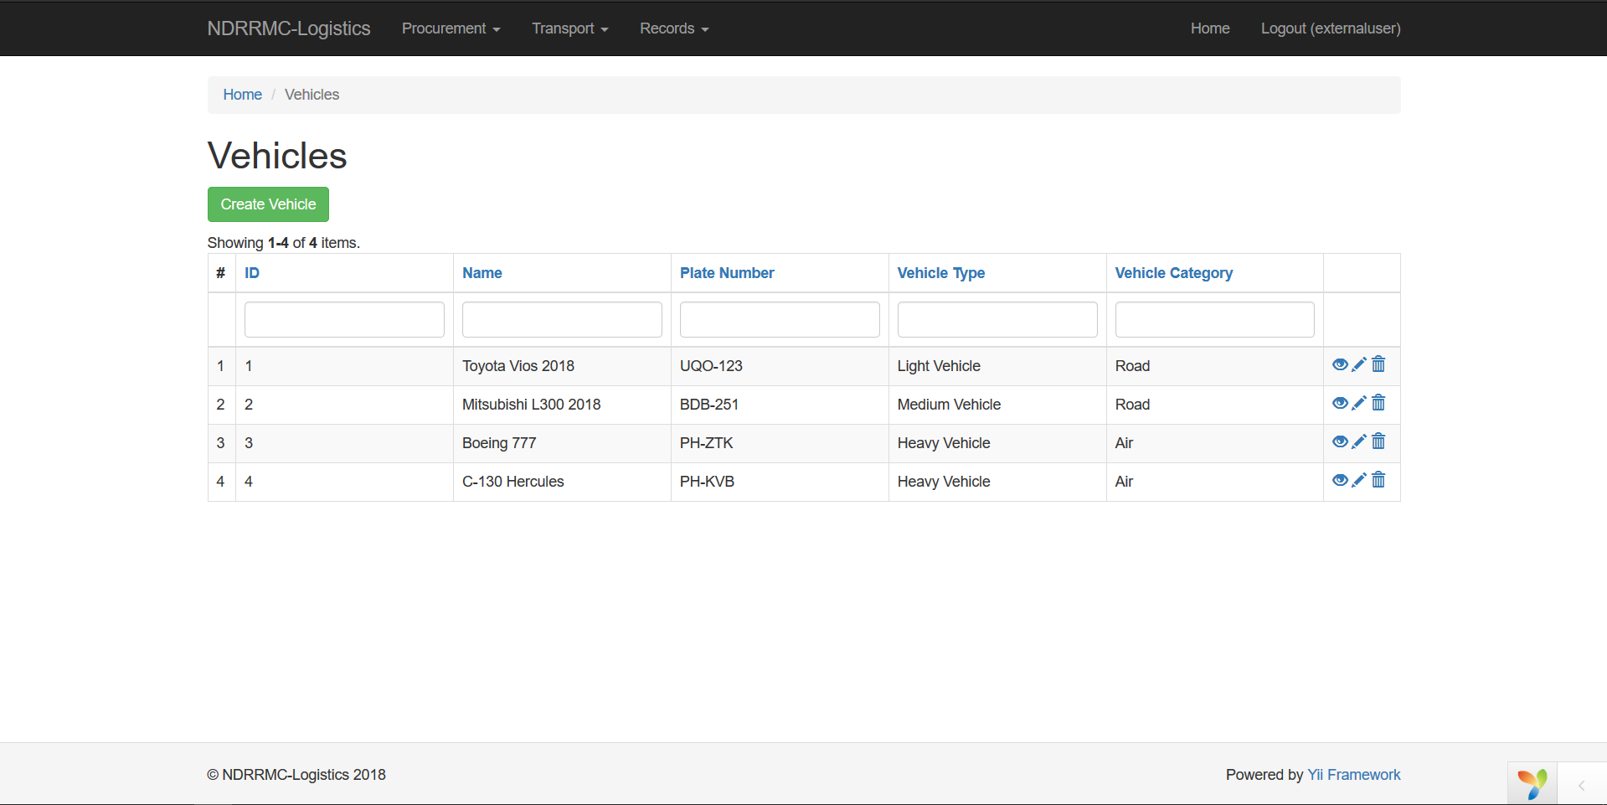

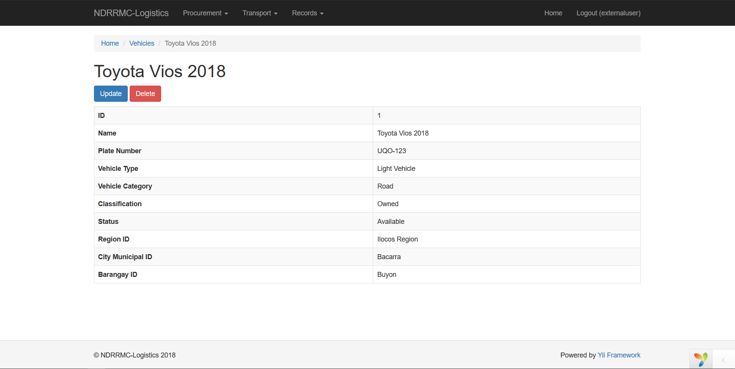

1. Updating Vehicles

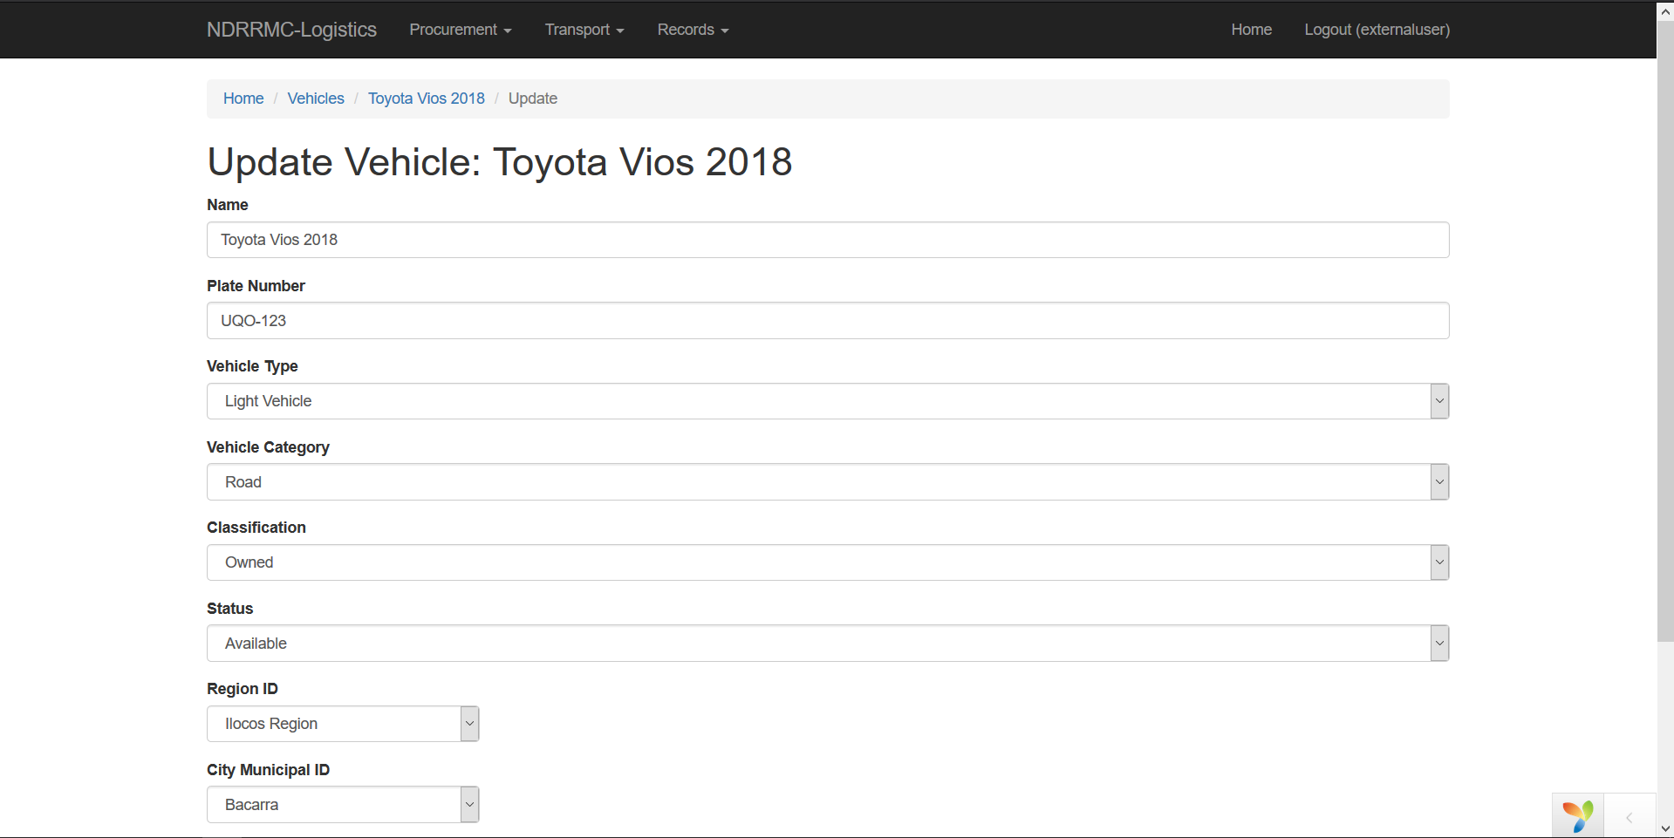

This system is also capable of creating SQL Reports through the Reportico Module

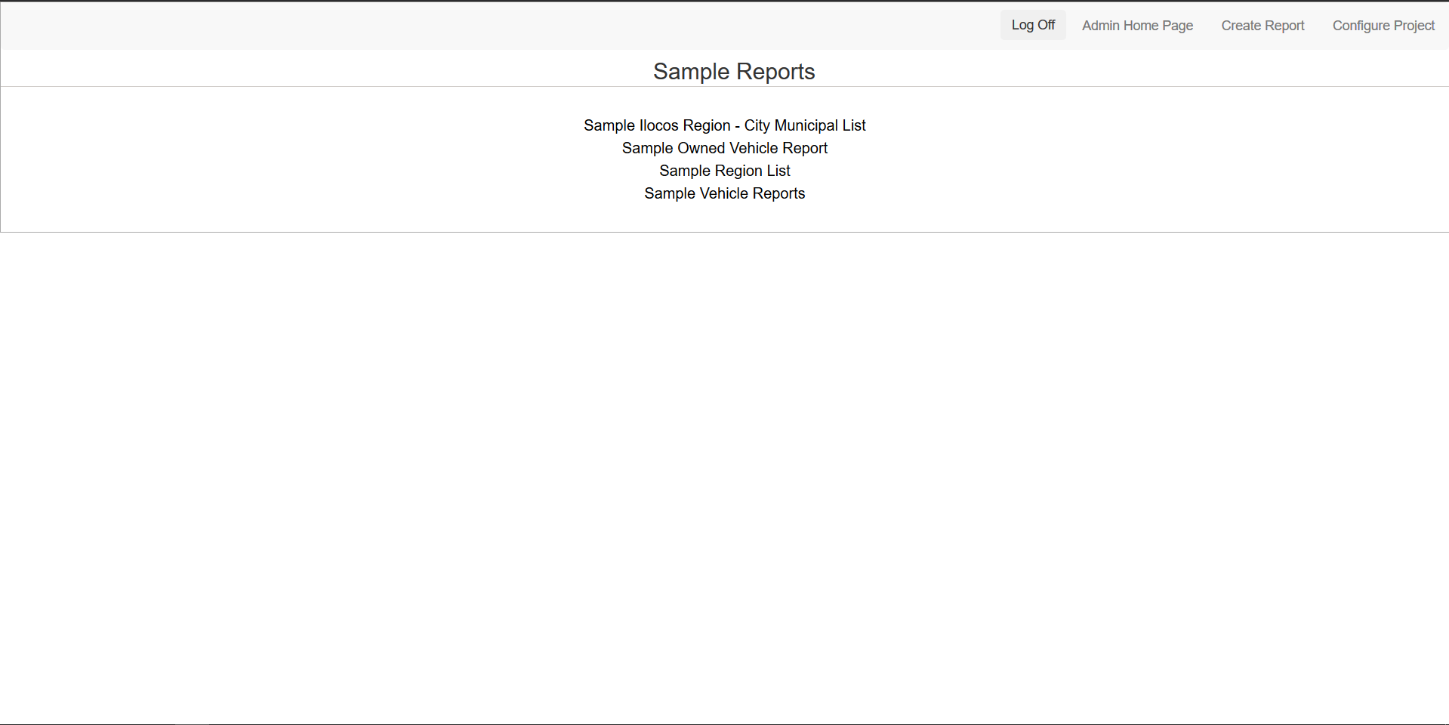

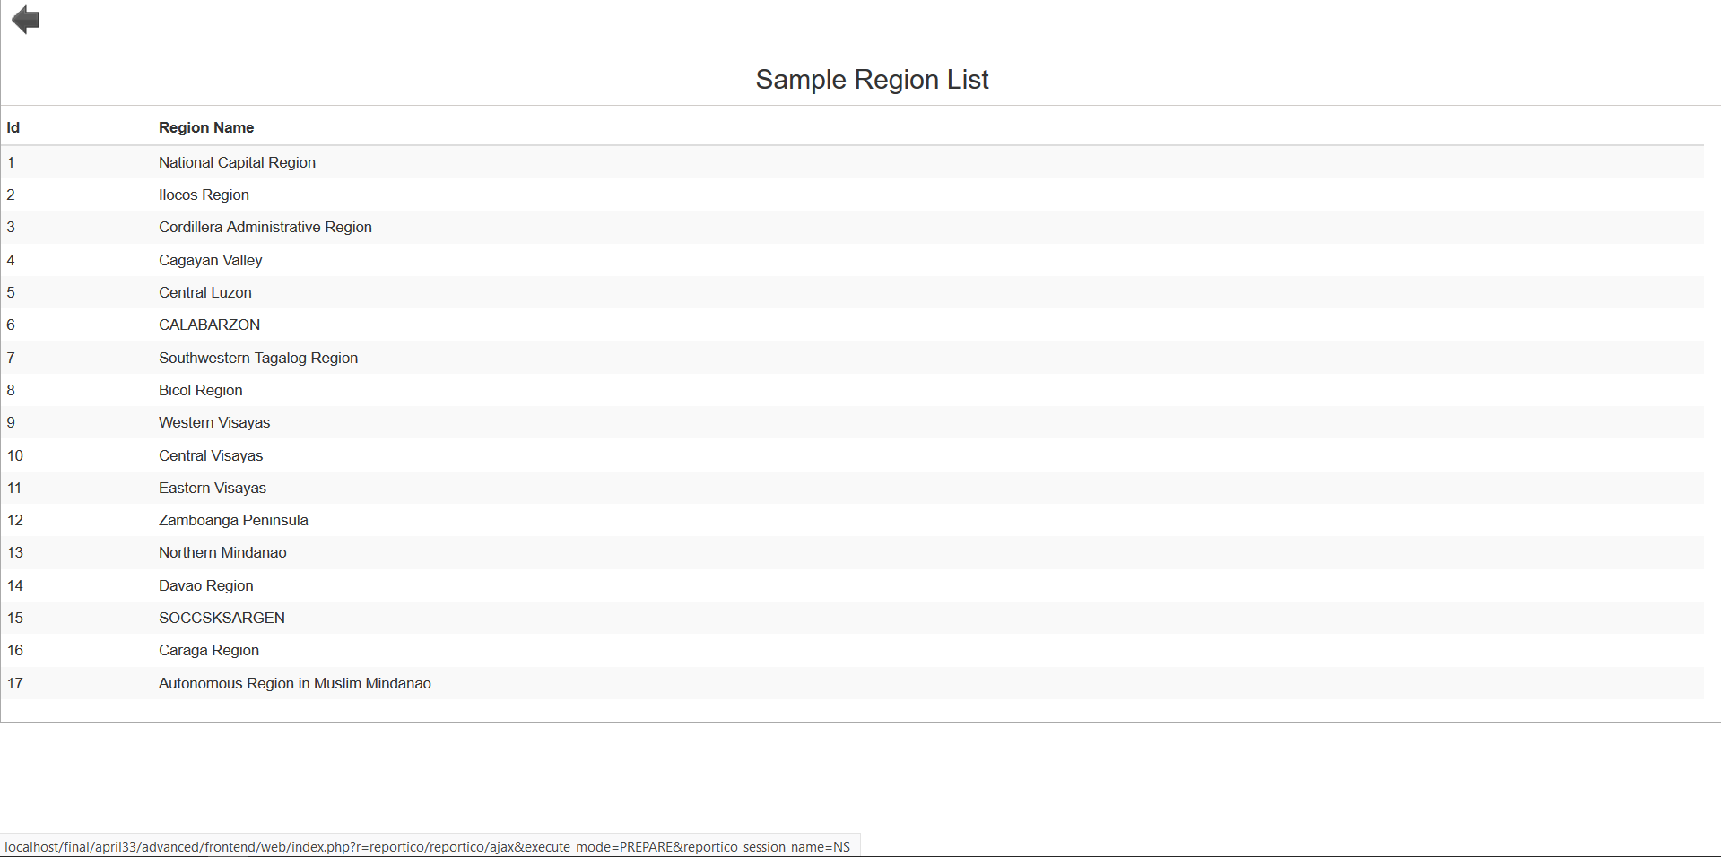

# SOURCE CODE LISTINGS

* This code checks the credentials of the user for it to be authenticated to log-in to the system.  
  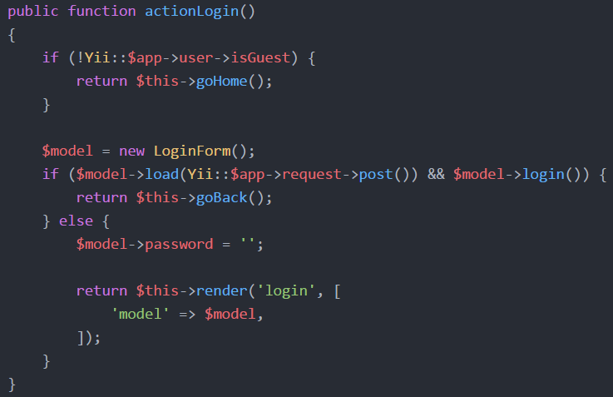
* This code exits the web-session and removes the user details.  
  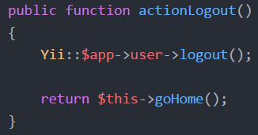
* This code redirects the user to the Home Page after signing up.  
  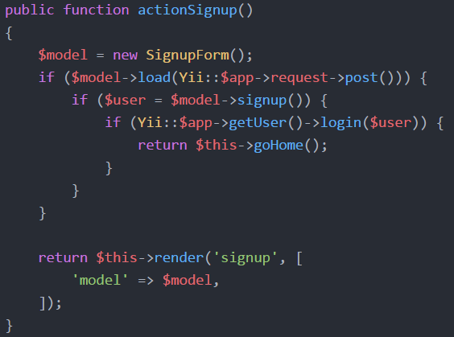
* This is the code for the Region Dropdown which is connected to the City-Municipal Dropdown field. This code alters the items displayed on the City-Municipal dropdown field depending on the chosen Region, it works by checking the database of the region and the city-municipal.  
  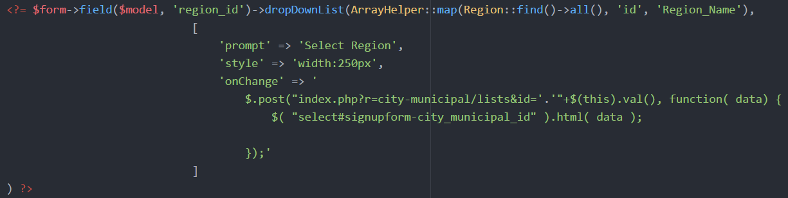
* This is the code for the City-Municipal Dropdown which is connected to the Barangay Dropdown field. This code alters the items displayed on the Barangay dropdown field depending on the chosen City-Municipal, it works by checking the database of the city-municipal and barangay.   
  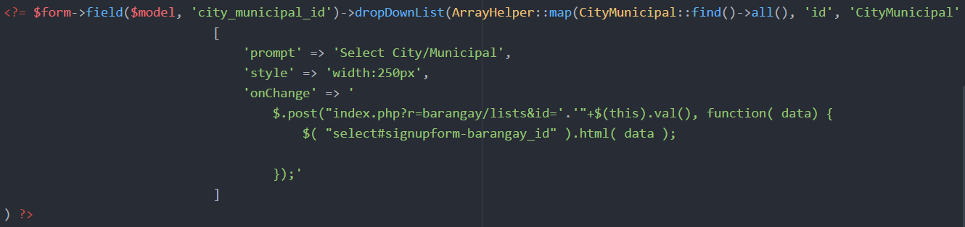
* This is the code that calls the DateTimePicker widget that helps the user to easily change the date through an interactive calendar.  
  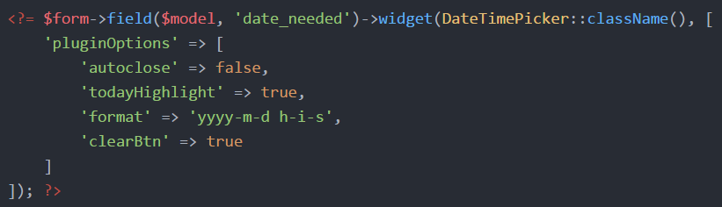
* This code checks the current user of the web session to be used for the requesting of resources and vehicles.  
  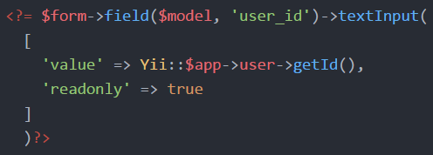
* This code checks all the suppliers in the database and displays their name in a dropdown list.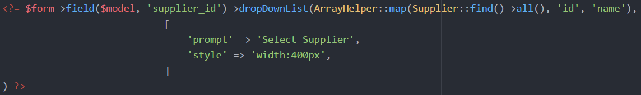
* This code checks all the locations in the database and displays their names in a dropdown list.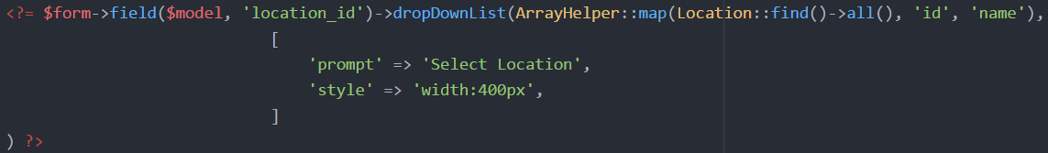
* This code checks all the resources in the database and displays their names in a dropdown list.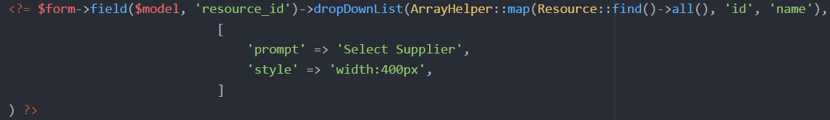
* This code filters the actions that the current user can perform while using the system.  
  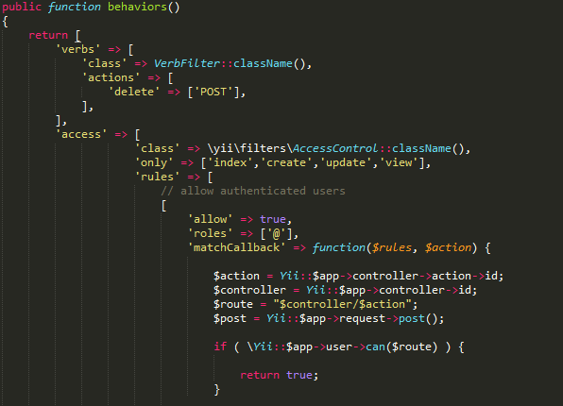
* This code gets the username of the current user to be used for the AccesControl feature of the system.  
  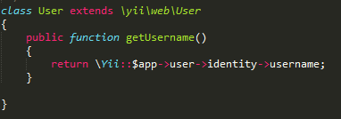

# REFERENCES

Department of Education. (2008). *Disaster Risk Reduction Resource Manual.* Retrieved from Disaster Risk Reduction Resource Manual: http://www.deped.gov.ph/sites/default/files/Disaster%20Risk%20Reduction%20Resource%20Manual.pdf

Office of Civil Defense. (2015, February 16). *OCD Operation Manual for Response.* Retrieved from Office of Civil Defense: http://ocd.gov.ph/attachments/article/144/OCD_Operation_Manual_for_Response.pdf

Office of Civil Defense. (2017, January). *Freedom of Information Manual.* Retrieved from Office of Civil Defense: http://ocd.gov.ph/attachments/article/387/OCD_FOI_Manual_Aug2017.pdf

Office of Civil Defense. (n.d.). *National Disaster Risk Reduction and Management Council*. Retrieved from http://www.ndrrmc.gov.ph